

Class&Tech Mobile Store

Senior Project By

# Rozan El Majzoub

Submitted to the School of Arts&Science of the

Lebanese International University – Bekaa Campus, Lebanon

In part of fulfillment of the requirements for the degree of

**BACHERLOR OF SCIENCE IN**

## COMPUTER SCIENCE AND INFORMATION TECHNOLOGY

**Supervised by: Dr. Walid Amer**

Fall 2025-2026

**Dedication:**

To everyone who supported me during my academic journey and encouraged me to complete this project successfully.

**Acknowledgment:**

I would like to express my sincere gratitude to my instructor and colleagues for their guidance, feedback, and continuous support throughout the development of this project.

**Abstract:**

Class&Tech Mobile Store is a web-based e-commerce and management platform designed for selling mobile phones, accessories, and technology products. The system provides a complete online shopping experience for customers while offering administrators powerful tools to manage products, orders, users, deliveries, discounts, analytics, and reports. The platform aims to digitalize traditional mobile stores, reduce manual work, and provide real-time insights into sales and customer behavior. The system is built using modern web technologies including PHP, MySQL, HTML, CSS, JavaScript, and charting libraries for analytics.

Table of Contents

Rozan El Majzoub I

COMPUTER SCIENCE AND INFORMATION TECHNOLOGY I

1.1 Introduction 8

1.2 Objective 8

1.3 Scope 9

1.4 Technology Constraints: 9

1.5 Problem definition 10

1.6 Proposed Solution 10

1.7 Methodology 10

2.1 Functional Requirements&System Users 11

2.1.1 Guest User 11

2.1.2 Customer 11

2.1.3 Administrator 12

2.1.4 Delivery Staff 12

2.2 Non-Functional Requirements 12

2.3 UML Use Case Diagram&Scenario 13

2.3.1 Use Case Diagram 13

Guest Use Cases 13

Customer Use Cases 14

Delivery Staff Use Cases 15

Admin Use Cases 16

2.3.2 - Use Case Scenarios 17

Narrative 1: View Mobile Products 17

Version: 1 17

Narrative 2: Add Product to Cart 19

Version: 1 19

Narrative 3: Purchase Mobile Product (Checkout) 21

Version: 1 21

Narrative 4: Sign Up / Register Account 23

Version: 1 23

Narrative 5: Login 25

Version: 1 25

Narrative 7: Forgot Password 27

Version: 1 27

Narrative 8: Contact Support 29

Version: 1 29

Narrative 9: Generate Report 30

Version: 1 31

Narrative 10: Add Product Review 32

Version: 1 32

Narrative 11: Wishlist Management 34

Narrative 12: Apply Discount / Promo Code 36

Chapter 3 38

users 40

brands 40

carts 41

categories 41

deliveries 42

discounts 42

notifications 43

orders 44

order_items 45

password_reset 45

payments 45

products_main 46

product_discounts 46

product_images 47

product_variants 47

reviews 48

suppliers 48

wishlists 49

Implementation: 50

4.1 - Introduction: 50

4.2 - Project’s Parts: 50

4.2.1-Home Page: 50

Header Section 53

Logo and Branding 54

Search and Category Navigation Functionality 54

Category Selection (All Categories) 54

Voice Search Functionality 55

Integration Between Search and Categories 55

Wishlist Icon 56

Cart Icon 56

User Account Icon 56

Language Switcher 57

Navigation Bar 57

Hero Section (Image Slider) 57

Discounts Section 58

Featured Products Section 58

Reviews Section 59

Review Submission 59

Review Display 59

Footer Functionality&Workflow 59

Overall, Home Page Experience 61

4.2.2-Signup Page: 62

Customer Signup Form 62

4.2.3-Login Page: 64

Components and Functionality 65

4.2.4-Forgot password Page: 66

Components and Functionality: 66

4.2.5-About Page: 69

4.2.6-Pages Page: 70

Components and Functionality – Main Navigation Pages 70

4.2.7-Wishlist Page: 72

Components and Functionality – Wishlist Feature 72

4.2.8-SideBar Cart: 74

Components and Functionality – Sidebar Cart 75

4.2.9-Cart page&Checkout: 76

Components and Functionality – Cart Page 76

Components and Functionality – Checkout Page 77

Order Placement Workflow 78

*4.2.10-User Account icon:* 79

Components and Functionality – User Account Icon 79

Components and Functionality – Profile Page 80

4.2.12-Order History: 81

Components and Functionality – Order History 81

4.2.13-Products page: 83

Product Search&Filtering Workflow 83

Product Details Workflow 86

4.2.14-Admin Dashboard page: 90

Admin Dashboard Workflow 91

4.2.15-Manage Discounts: 93

4.2.16-Manage Products: 95

4.2.17-Manage Orders: 96

4.2.18-Manage Users: 98

4.2.19-Manage Reviews: 99

4.2.20-View Reports: 100

4.2.21-Analytics&Charts: 101

4.2.22-Manage Deliveries: 103

5.1 - Conclusion: 105

5.2 - Future Work: 107

# Chapter 1:

## 1.1 Introduction

The rapid advancement of information technology and the widespread availability of the internet have significantly transformed the way businesses operate. One of the most affected sectors is retail, particularly mobile phones and technology products. Customers today prefer online platforms that allow them to compare products, check specifications, view prices, and place orders without the limitations of time and physical location. Traditional mobile stores that rely solely on in-store sales face increasing challenges in maintaining competitiveness, managing inventory, and understanding customer behavior.

Mobile and technology products have short life cycles, frequent updates, and high customer demand. Managing such products manually often leads to stock shortages, inaccurate records, delayed orders, and customer dissatisfaction. Moreover, decision-making without proper analytics and reports limits the ability of store owners to plan promotions, discounts, and future investments effectively.

Class&Tech Mobile Store is proposed as a comprehensive web-based solution that addresses these challenges by integrating sales, inventory, customer management, delivery tracking, and analytics into a single platform. The system leverages modern web technologies to provide efficiency, accuracy, and scalability.

## 1.2 Objective

The primary aim of this project is to design and implement a secure, user-friendly, and scalable web-based mobile store management system.

The specific objectives are:

* To provide an online platform for selling mobile phones and technology products
* To allow customers to browse, search, and purchase products easily
* To enable administrators to manage products, categories, users, orders, and deliveries
* To implement discount and promotion management features
* To generate reports and analytics for informed decision-making
* To improve overall customer satisfaction and business efficiency

## 1.3 Scope

The scope of Class&Tech Mobile Store includes:

* User authentication and role management
* Product and category management
* Shopping cart and order processing
* Discount and promotion handling
* Delivery assignment and tracking
* Admin dashboard with reports and analytics

The system does not include third-party payment gateway integration in the current version but is designed to support future enhancements.

## 1.4 Technology Constraints:

**Software:** XAMPP, Visual Studio Code

**Languages:** PHP, HTML, CSS, JavaScript

**Database:** MySQL

**Libraries:** Chart.js / Recharts, Bootstrap / Tailwind

**Hardware:** Laptop or PC

## 1.5 Problem definition

Despite the growth of the mobile and technology market, many small and medium-sized stores still rely on traditional methods such as manual record keeping or basic systems that lack integration. These methods present several problems, including inaccurate inventory tracking, difficulty in managing customer orders, lack of real-time sales data, and limited visibility into business performance.

Customers also face difficulties such as limited product information, inability to track orders, and lack of transparency in pricing and discounts. Administrators, on the other hand, struggle with generating reports, managing deliveries, and monitoring sales trends. These issues highlight the need for a centralized and automated system that can handle all operational aspects efficiently.

## 1.6 Proposed Solution

Class&Tech Mobile Store solves these issues by:

* Automating inventory and order processing
* Providing real-time analytics and reports
* Offering an online storefront for customers
* Centralizing data for better decision-making

## 1.7 Methodology

The development of the system follows a structured methodology that includes requirement analysis, system design, implementation, testing, and deployment. User requirements are gathered through analysis of existing e-commerce systems and market needs. The system is designed using modular architecture to ensure maintainability and scalability.

# Chapter 2

This chapter presents a detailed functional and conceptual analysis of the Class&Tech Mobile Store system. It focuses on identifying system users, defining their interactions with the system, and specifying both functional and non-functional requirements. This study serves as the foundation for system design and implementation, ensuring that all user needs and business processes are clearly understood and properly addressed.

## 2.1 Functional Requirements&System Users

Functional requirements define what the system must do. These requirements are grouped based on user roles.

### 2.1.1 Guest User

A guest user is any visitor who accesses the system without authentication.

**Responsibilities:**

* View homepage and featured products
* Browse product categories
* View product details
* Register or login to the system

## 2.1.2 Customer

A customer is a registered user who can purchase products from the store.

**Responsibilities:**

* Manage personal profile
* Browse and search products
* Add products to cart
* Place and track orders
* Apply discount codes
* View order history
* Track delivery status

### 2.1.3 Administrator

The administrator manages all system operations through the admin dashboard.

**Responsibilities:**

* Manage users and roles
* Manage products and categories
* Manage orders and order statuses
* Manage discounts and promotions
* Assign and manage deliveries
* View reports and analytics

### 2.1.4 Delivery Staff

Delivery staff are responsible for delivering customer orders.

**Responsibilities:**

* View assigned deliveries
* Update delivery status

## 2.2 Non-Functional Requirements

* **Security:** Secure login and password hashing
* **Performance:** Fast page loading
* **Usability:** User-friendly interface
* **Reliability:** Data consistency and error handling
* **Scalability:** Support growing number of products and users

## 

## 2.3 UML Use Case Diagram&Scenario

### 2.3.1 Use Case Diagram

#### Main Actors

1. Guest

A non-registered visitor who can explore basic features and initiate sign-up.

1. Customer

A registered user eligible to order products easily. Can view/add to Wishlist/add to cart and manage profile.

1. Delivery Staff

Delivery guy users who deliver orders to customers door and change order status to delivered.

1. Admin

System moderator who manages users, approvals, and monitors order activity.

#### Use Cases by Actor

## Guest Use Cases

* **View Homepage**  
   Include: View featured products, promotions, categories
* **View Product Catalog**  
   Include: Browse categories, filter by price, brand, availability  
   Include: View product images, specifications, and prices
* **View Store Information**  
   Include: View store location, contact details, working hours
* **Sign Up**  
   Include: Choose account type (Customer)  
   Include: Fill registration form  
   Include: Email verification
* **Login**  
   Include: Enter credentials  
   Include: System authentication  
   Extend: Forgot Password  
    ▪ Fill reset form  
    ▪ Verify email
* **View FAQs**
* **Contact Support**  
   Include: Fill contact form  
   Include: Send inquiry or feedback

## Customer Use Cases

* **Complete Profile Setup**  
   Include: Provide personal information  
   Include: Provide contact details  
   Include: Manage delivery address
* **Browse and Search Products**  
   Include: Filter by category, brand, price  
   Include: View product details
* **Add Products to Cart**  
   Include: Update quantity  
   Include: Remove items
* **Place Order**  
   Include: Review cart  
   Include: Apply discount code  
   Include: Confirm order
* **Track Order Status**  
   Extend: View order details  
   Extend: View delivery progress
* **View Order History**
* **Receive Notifications**  
   Include: Order confirmation  
   Include: Order status updates  
   Include: Promotional offers
* **Update Profile and Preferences**  
   Include: Update personal information  
   Include: Update password
* **Manage Account**  
   Include: View account details  
   Include: Logout

## Delivery Staff Use Cases

* **View Assigned Deliveries**  
   Include: View order details  
   Include: View customer address
* **Update Delivery Status**  
   Extend: Mark as picked up  
   Extend: Mark as delivered
* **Receive Delivery Notifications**

## Admin Use Cases

* **Manage User Accounts**  
   Include: View user profiles  
   Include: Suspend or activate users
* **Manage Products**  
   Include: Add products  
   Include: Edit product details  
   Include: Delete products
* **Manage Categories**
* **Manage Orders**  
   Include: View all orders  
   Extend: Update order status  
   Extend: Assign delivery staff
* **Manage Discounts and Promotions**  
   Include: Create discount codes  
   Include: Set expiry dates
* **View and Generate Reports**  
   Include: Sales reports  
   Include: Product performance reports  
   Include: Customer activity reports
* **View Analytics and Charts**  
   Include: Revenue charts  
   Include: Monthly sales analysis
* **Receive System Notifications**

### 2.3.2 - Use Case Scenarios

In this part we will be explaining all the mentioned use cases of the ~~customer~~ in details, regarding primary actors, main flow, and the alternative one. In addition to a short description for each use case ma king all points clear.

# Narrative 1: View Mobile Products

**Author(s):** Rozan Al Majzoub **Date:** 06/01/2026

## Version: 1

|  |  |  |
| --- | --- | --- |
| **Use-Case Name:** | View Mobile Products | **Use-Case Type:**  **Business Requirement** |
| **Use-Case ID:** | MBL-VP001.00 |
| **Priority:** | Medium |
| **Source:** | Requirement – SYS-FR001 |
| **Primary**  **Business Actor:** | Guest User | |
| **Other**  **Participating Actors:** | Customer, Admin | |
| **Other Interested Stakeholders:** | Admin, Supplier | |
| **Description:** | This use case allows any actor (Guest, Customer, Admin) to view a list of mobile products available in the Class&Tech platform. The information displayed varies depending on the user’s role:   * **Guest users** see basic product information: name, brand, price, main specifications, and basic images. They cannot view stock availability, detailed specifications, or reviews. * **Customers** see detailed product specifications, current discounts, stock availability, and customer reviews. They can also add products to their cart or Wishlist. * **Admins** have access to full product information including supplier details, stock history, sales performance, and low-stock alerts. | |
| **Precondition:** | The system must have registered and approved mobile products. | |
| **Trigger:** | The actor accesses the "Products" section from the main navigation or homepage. | |

|  |  |  |
| --- | --- | --- |
| **Typical Course of Events:** | **Actor Action** | **System Response** |
| **Step 1:** Actor selects "View Products"  **Step 3:** Actor browses product categories or searches for a specific mobile  **Step 5**: Actor applies filters (brand, price range, features) | **Step 2:** System verifies actor’s access level  **Step 4:** System fetches product data appropriate to the actor’s role  **Step 6:** System updates the list dynamically based on filters |
| **Conclusion:** | This use case allows any actor (Guest, Customer, Admin) to view a list of mobile products available in the Class&Tech platform. The information displayed varies depending on the user’s role:   * **Guest users** see basic product information: name, brand, price, main specifications, and basic images. They cannot view stock availability, detailed specifications, or reviews. * **Customers** see detailed product specifications, current discounts, stock availability, and customer reviews. They can also add products to their cart or Wishlist. * **Admins** have access to full product information including supplier details, stock history, sales performance, and low-stock alerts. | |

# Narrative 2: Add Product to Cart

**Author(s):** Rozan Al Majzoub **Date:** 06/01/2026

## Version: 1

|  |  |  |
| --- | --- | --- |
| **Use-Case Name:** | Add Product to Cart | **Use-Case Type:**  **Business Requirement** |
| **Use-Case ID:** | MBL-AC001.00 |
| **Priority:** | High |
| **Source:** | Requirement – SYS-FR002 |
| **Primary**  **Business Actor:** | Customer |  |

|  |  |  |  |  |
| --- | --- | --- | --- | --- |
| **Other**  **Participating Actors:** | Admin (for stock verification) | | | |
| **Other Interested Stakeholders:** | Supplier | | | |
| **Description:** | This use case allows a logged-in customer to add mobile products to their shopping cart. The system checks availability and updates the cart for further actions (checkout or continue shopping). | | | |
| **Precondition:** | Customer must be logged in and have an active account. | | | |
| **Trigger:** | Customer clicks “Add to Cart” on a product page. | | | |
| **Typical Course of Events:** | **Actor Action** | | **System Response** |  |
| **Step 1:** Customer clicks “Add to Cart” on a mobile product.  **Step 3:** Customer adjusts quantity or options (color, storage).  **Step 5:** Customer confirms addition. | | **Step 2:** System checks product availability.    **Step 4:** System validates stock and updates cart.    **Step 6:** System saves cart data and shows confirmation. |
| **Conclusion:** | | The use case concludes when the product is successfully added to the cart.   * The customer can continue shopping, proceed to checkout, or remove items. * The system ensures stock levels are respected, prevents over-ordering, and dynamically applies promotions. * Admins can monitor cart activity and stock reduction in real-time, ensuring inventory integrity. | |
| **Extensions / Alternative Flows:** | | • Product out of stock → System displays “Out of Stock” message.  • Quantity exceeds available stock → System suggests maximum available quantity. | |

# Narrative 3: Purchase Mobile Product (Checkout)

**Author(s):** Rozan Al Majzoub **Date:** 06/01/2026

## Version: 1

|  |  |  |  |  |
| --- | --- | --- | --- | --- |
| **Use-Case Name:** | Checkout | | **Use-Case Type:**  **Business Requirement** | |
| **Use-Case ID:** | MBL-PC001.00 | |
| **Priority:** | High | |
| **Source:** | Requirement – SYS-FR003 | |
| **Primary**  **Business Actor:** | Customer | | | |
| **Other**  **Participating Actors:** | Payment Gateway, Admin | | | |
| **Other Interested Stakeholders:** | Supplier, Logistics | | | |
| **Description:** | Customers complete purchase, system processes payment, updates inventory, and notifies admin/logistics. | | | |
| **Precondition:** | * Cart has items, valid payment method. | | | |
| **Trigger:** | Customer clicks "Checkout". | | | |
| **Typical Course of Events:** | **Actor Action** | **System Response** | |  |
| **Step 1:** Review cart, click "Proceed to Checkout".    **Step 3:** Fill shipping/payment info.  **Step 5:** Confirm purchase.  **Step 7:** System sends order confirmation | **Step 2:** System displays checkout form.    **Step 4:** System validates and checks stock.  **Step 6:** System processes payment, creates order  **Step 8:** Admin/logistics notified | |
| **Conclusion:** | The use case concludes when the order is successfully placed, payment is processed, and the customer receives a confirmation.   * Customers can track order status, request changes, or cancel if allowed. * Admins and logistics use the system to manage stock, shipment, and notifications. * Finance teams ensure revenue and transaction tracking is accurate. | | |
| **Extensions / Alternative Flows:** | •**E1:** If payment fails → System displays the error message from the payment gateway and allows the customer to retry or choose another payment method.  •**E2:** If the shipping address is invalid → System prompts the user to correct the address before proceeding.  •**E3:** If stock becomes unavailable during checkout → System notifies the customer and updates the cart automatically to remove unavailable items. | | |

# Narrative 4: Sign Up / Register Account

**Author(s):** Rozan Al Majzoub **Date:** 06/01/2026

## Version: 1

|  |  |  |  |
| --- | --- | --- | --- |
| **Use-Case Name:** | Sign Up | | **Use-Case Type:**  **Business Requirement** |
| **Use-Case ID:** | MBL-SU001.00 | |
| **Priority:** | High | |
| **Source:** | User Requirement – SYS-FR004 | |
| **Primary**  **Business Actor:** | Guest User | | |
| **Other**  **Participating Actors:** | Admin (for approval, if seller account) | | |
| **Other Interested Stakeholders:** | Customer, Admin, Supplier | | |
| **Description:** | This use case allows a guest to register as a customer or seller on the Class&Tech platform. Customers can browse, purchase, and review products, while sellers can list products for sale. Admin approval may be required for seller accounts. | | |
| **Precondition:** | •User must not be logged in.  •Platform must allow account creation. | | |
| **Trigger:** | User clicks “Sign Up” from the homepage or login page. | | |
| **Typical Course of Events:** | **Actor Action** | **System Response** | |
| **Step 1:** Guest selects account type (Customer or Seller).  **Step 3:** User enters required information: name, email, password, phone, and (for sellers) business info.  **Step 5:** User submits form.  **Step 7:** User clicks verification link. | **Step 2:** System displays the appropriate registration form.    **Step 4:** System validates fields, checks email uniqueness.    **Step 6:** System creates account with status = Pending Activation; sends verification email.  **Step 8:** System activates customer account or flags seller for admin approval. | |
| **Conclusion:** | The use case concludes when the account is created, email verified, and the user is redirected to profile setup or waiting for approval. Customers can immediately log in; sellers wait for admin approval. | | |
| **Extensions / Alternative Flows:** | * Email already in use → System prompts: “Email already registered.” * Weak password → System requests a stronger password. * Admin rejects seller registration → System notifies user. | | |

# Narrative 5: Login

**Author(s):** Rozan Al Majzoub **Date:** 06/01/2026

## Version: 1

|  |  |  |  |
| --- | --- | --- | --- |
| **Use-Case Name:** | Login | | **Use-Case Type:**  **Business Requirement** |
| **Use-Case ID:** | MBL-LO001.00 | |
| **Priority:** | High | |
| **Source:** | User Requirement – SYS-FR006 | |
| **Primary**  **Business Actor:** | Customer or Delivery | |  |
| **Other**  **Participating Actors:** | Admin | |  |
| **Other Interested Stakeholders:** | Platform Users | |  |
| **Description:** | Allows registered users (Customers, Deliveries, Admin) to access the platform using valid credentials. Users are redirected to role-specific dashboards. | | |
| **Precondition:** | User must have an active account. | | |
| **Trigger:** | User clicks “Login” on the homepage. | | |
| **Typical Course of Events:** | **Actor Action** | **System Response** | |
| **Step 1:** User enters email/username and password.    **Step 3:** User clicks “Login.”    **Step 5:** Credentials valid → System logs user in. | **Step 2:** System validates credentials.    **Step 4:** System checks account status (active, pending, suspended).    **Step 6:** System creates session and redirects to dashboard. | |
| **Conclusion:** | Login is successful when the user is authenticated and redirected appropriately. | | |
| **Extensions / Alternative Flows:** | * Invalid credentials → Error message displayed. * Forgot password → Redirect to reset flow. | | |

# Narrative 7: Forgot Password

**Author(s):** Rozan Al Majzoub **Date:** 06/01/2026

## Version: 1

|  |  |  |  |
| --- | --- | --- | --- |
| **Use-Case Name:** | Forgot Password | | **Use-Case Type:**  **Business Requirement** |
| **Use-Case ID:** | MBL-FP001.00 | |
| **Priority:** | Medium | |
| **Source:** | User Convenience – SYS-FR007 | |
| **Primary**  **Business Actor:** | Customer or Delivery | | |
| **Other**  **Participating Actors:** | Admin (monitoring resets) | | |
| **Other Interested Stakeholders:** | Platform Users | | |
| **Description:** | Allows users who forgot their password to reset it securely via email. Users can regain access by verifying ownership of the account. | | |
| **Preconditions:** | User must have a registered, active account. | | |
| **Trigger:** | User clicks “Forgot Password?” on the login page. | | |
| **Typical Course of Events:** | **Actor Action** | **System Response** | |
| **Step 1:** User clicks “Forgot Password?”  **Step 3:** User enters email and submits.    **Step 5:** System sendsverification code/link to email.  **Step 7**: User enters code, new password, confirms. | **Step 2:** System displays email input form.    **Step 4:** System checks email validity and account status.    **Step 6:** User receives code/link.    **Step 8:** System validates password, updates database, and confirms reset. | |
|  |  |  | |
| **Conclusion:** | User can now log in using the new password. | | |
| **Extensions / Alternative Flows:** | * Email not registered → Error: “No account found with that email.” * Reset link expired → System prompts to request a new one. * Weak password → System requests stronger password. | | |

# Narrative 8: Contact Support

**Author(s):** Rozan Al Majzoub **Date:** 06/01/2026

## Version: 1

|  |  |  |  |
| --- | --- | --- | --- |
| **Use-Case Name:** | Contact Support | | **Use-Case Type:**  **Business Requirement** |
| **Use-Case ID:** | MBL-CS001.00 | |
| **Priority:** | Medium | |
| **Source:** | User Convenience – SYS-FR008 | |
| **Primary**  **Business Actor:** | Guest, Customer, Delivery | | |
| **Other**  **Participating Actors:** | Admin (recipient) | | |
| **Other Interested Stakeholders:** | Platform Management | | |
| **Description:** | Allows users to contact support by clicking on contact link that open WhatsApp and takes user to admin number. | | |
| **Preconditions:** | User has access to the platform or guest interface. | | |
| **Trigger:** | The user clicks the **“Contact Us”** link in the navigation bar. | | |
| **Typical Course of Events:** | **Actor Action** | **System Response** | |
| **Step 1:** The user clicks the  **“Contact Us”** link in the navigation bar.    **Step 3:** The user is taken directly to WhatsApp by opening another tab in the platform such as chrome or Microsoft edge and taken to the number so he can freely talk with admin no form. | **Step 2:** System displays contact form.    **Step 4:** The system opens link in new tab | |
| **Conclusion:** | The user successfully sends a message to the Admin. | | |

# Narrative 9: Generate Report

**Author(s):** Rozan Al Majzoub **Date:** 06/01/2026

## Version: 1

|  |  |  |  |
| --- | --- | --- | --- |
| **Use-Case Name:** | Generate Report | | **Use-Case Type:**  **Business Requirement** |
| **Use-Case ID:** | MBL-GR001.00 | |
| **Priority:** | Medium | |
| **Source:** | Admin Functional Requirement – SYS-FR009 | |
| **Primary**  **Business Actor:** | Admin | | |
| **Other**  **Participating Actors:** |  | | |
| **Other Interested Stakeholders:** | Platform Management | | |
| **Description:** | Admin can generate reports for sales, inventory, orders, and customer activity over a selected period. | | |
| **Preconditions:** | Admin must be logged in | | |
| **Trigger:** | The Admin clicks the **“Download CSV”** on top of the table of results. | | |
| **Typical Course of Events:** | **Actor Action** | **System Response** | |
| **Step 1:** Admin navigates to reports section.    **Step 3:** Admin selects filters, clicks “Download CSV.”  **Step 5:** CSV downloaded to admin’s device. | **Step 2:** System displays available data tables.    **Step 4:** System generates CSV with selected data.    **Step 6:** System confirms successful download. | |
| **Conclusion:** | Admin successfully generates and downloads a report for operational use. | | |
| **Extensions / Alternative Flows:** | No data matching filters → System displays “No data found.” | | |

# Narrative 10: Add Product Review

**Author(s):** Rozan Al Majzoub **Date:** 06/01/2026

## Version: 1

|  |  |  |  |
| --- | --- | --- | --- |
| **Use-Case Name:** | Add Product Review | | **Use-Case Type:**  **Business Requirement** |
| **Use-Case ID:** | MBL-PR001.00 | |
| **Priority:** | Medium | |
| **Source:** | Customer Requirement – SYS-FR010 | |
| **Primary**  **Business Actor:** | Customer | | |
| **Other**  **Participating Actors:** | Admin, Logistics | | |
| **Other Interested Stakeholders:** | Other Customers | | |
| **Description:** | Allows logged-in customers to add reviews and ratings for purchased products. Reviews help other customers make purchase decisions and allow sellers and admins to monitor product satisfaction. | | |
| **Preconditions:** | •Customer must be logged in.  •Customer must have purchased the product. | | |
| **Trigger:** | Customer clicks “Write a Review” on a product page. | | |
| **Typical Course of Events:** | **Actor Action** | **System Response** | |
| **Step 1:** Customer clicks “Write Review.”    **Step 3:** Customer enters review text, selects rating.    **Step 5:** Customer submits review.    **Step 7:** System displays the review publicly once approved (optional admin moderation). | **Step 2:** System displays review form with rating options.    **Step 4:** System validates input.    **Step 6:** System stores review in database, associates it with customer and product. | |
|  |  |
| **Conclusion:** | The customer successfully submits a review, which is visible to others depending on moderation settings. Reviews improve transparency and trust on the platform. | | |
| **Extensions / Alternative Flows:** | * Customer tries to review without purchase → System blocks action and displays message: “You must purchase this product to review it.” * Review contains inappropriate content → System flags for admin approval. | | |

## ****Narrative 11: Wishlist Management****

**Author(s):** Rozan Al Majzoub  
**Date:** 06/01/2026  
**Version:** 1

|  |  |  |  |
| --- | --- | --- | --- |
| **Use-Case Name:** | Wishlist Management | | **Use-Case Type:**  **Business Requirement** |
| **Use-Case ID** | MBL-WL001.00 | |
| **Priority:** | Medium | |
| **Source:** | User Requirement – SYS-FR012 | |
| **Primary Business Actor:** | Customer | |
| **Other Participating Actors:** | Admin | |
| **Other Interested Stakeholders:** | Seller | |
| **Description:** | Allows customers to add products to a wishlist for future reference. Products in the wishlist can later be moved to cart or removed. | |
| **Precondition:** | * Customer must be logged in. | |
| **Trigger:** | * Customer clicks “Add to Wishlist” on a product page. | |
| **Typical Course of Events:** | | **Actor Action** |  | | --- | --- | | **System Response** |
| |  | | --- | | **Step 1:** Customer clicks “Add to Wishlist.” | | **Step 3:** System adds product to wishlist. | | **Step 5:** Customer can view wishlist, remove items, or move items to cart. | | |  | | --- | | **Step 2:** System verifies login and product availability. | | **Step 4:** System confirms addition with a message. | | **Step 6:** System updates wishlist dynamically. | |
| **Conclusion:** | The customer successfully manages wishlist items for future shopping. Wishlist data helps the platform understand user preferences. | |
| **Extensions / Alternative Flows:** | * Product no longer available → System removes it from wishlist and notifies user. * Customer not logged in → System prompts login before adding to wishlist. | |

## ****Narrative 12: Apply Discount / Promo Code****

**Author(s):** Rozan Al Majzoub  
**Date:** 06/01/2026  
**Version:** 1

|  |  |  |  |
| --- | --- | --- | --- |
| **Use-Case Name:** | Apply Discount / Promo Code | | **Use-Case Type:**  **Business Requirement** |
| **Use-Case Type:** | Business Requirement | |
| **Use-Case ID:** | MBL-DP001.00 | |
| **Priority:** | Medium | |
| **Source:** | Business Requirement – SYS-FR013 | |
| **Primary Business Actor:** | Customer | |
| **Other Participating Actors:** | Admin | |
| **Other Interested Stakeholders:** | Seller | |
| **Description:** | Allows customers to apply a discount code or promotion during checkout. The system validates the code, applies the discount, and updates the total amount. | |
| **Precondition:** | Customer must be logged in and have items in cart. | |
| **Trigger** | Customer enters discount code on the checkout page. | |
| **Typical Course of Events** | **Actor Action** | **System Response** |
| | **Step 1:** Customer enters promo code. | | --- | | **Step 3:** Customer clicks “Apply.” | | **Step 5:** Customer confirms purchase. | | |  | | --- | | **Step 2:** System verifies code validity, expiration, and usage limits. | | **Step 4:** System calculates discount and updates total. | | **Step 6:** System finalizes order with discount applied. | |
| **Conclusion:** | The customer successfully applies valid promo codes to receive discounts. Admin can monitor promo usage for marketing analytics. | |
| **Extensions / Alternative Flows:** | Invalid or expired code → System displays  “Promo code invalid or expired.”  Code already used → System displays  “You have already used this promo code.” | |

## Chapter 3

This chapter describes the system design, including the data base of our project, the related tables and the relations between them.

**3.1 - System Design:**

**3.1.1 - ER-Diagram**

The Entity Relationship Diagram (as shown in **Figure 2: ER Diagram**) represents the core data model of the Class&Tech system. It illustrates how different tables such as Users, Discounts, Products, Cart, Orders and Notifications are related and how data flows between actors and modules. In this ERD not all tables are present because it is only showing the primary tables with attributes and relations between them like one to one, one to many and many to many later when creating the database tables the many to many relations are dropped into new tables with FK taken from both tables that has this relation because in database logic many to many can not be represented unless another table is created that joins both fk and of course some new attributes like created-at, quantity, etc…

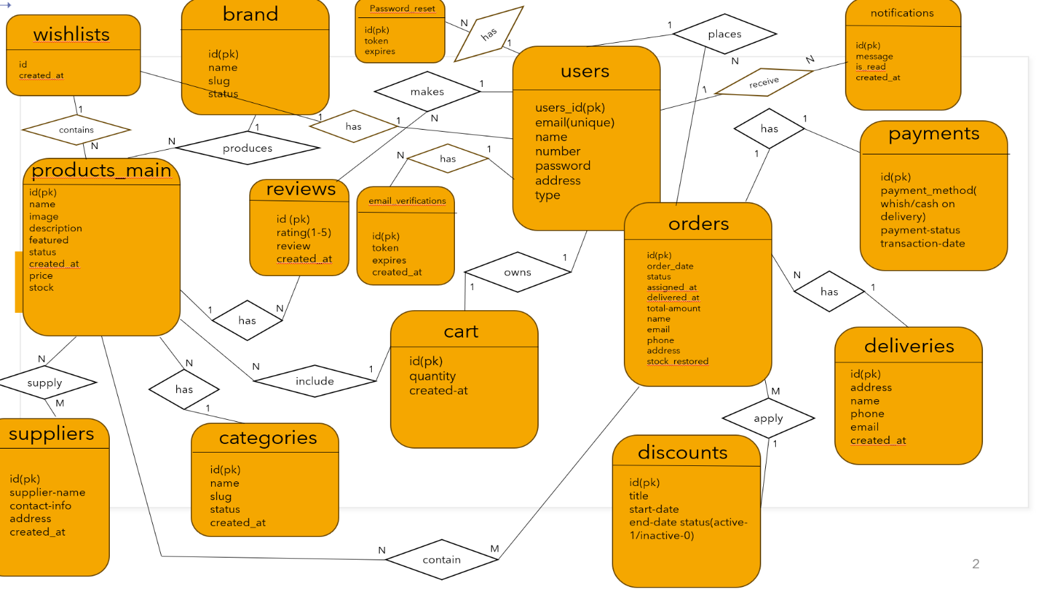

*Figure 2: ER Diagram*

**Class&Tech database tables:**

### users

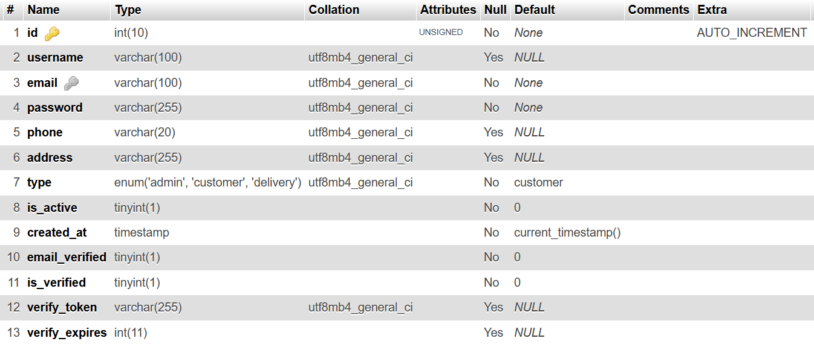

### brands

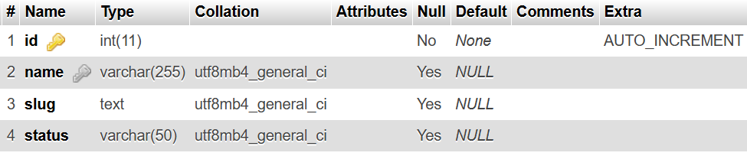

### carts

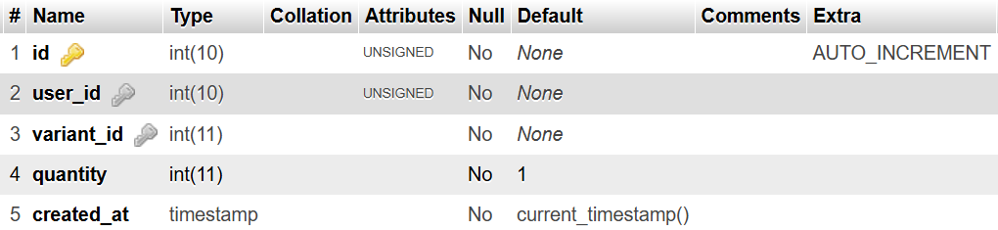

### categories

|  |
| --- |
|  |

### deliveries

### discounts

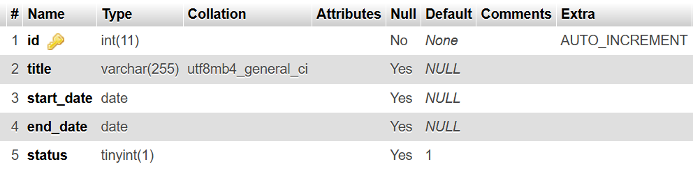

**email_verifications**

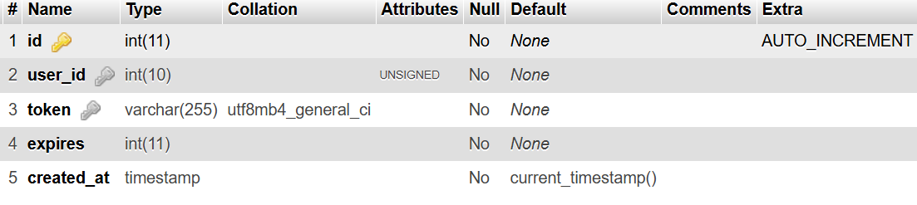

### notifications

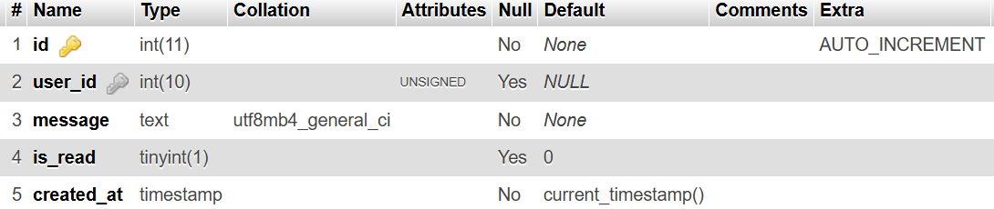

### orders

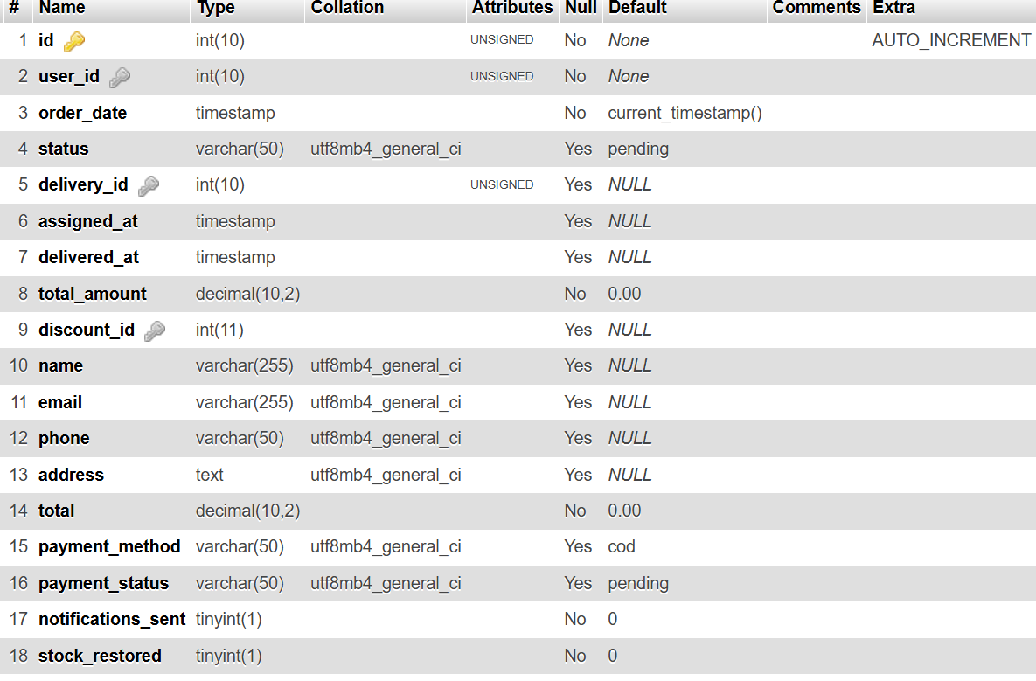

### order_items

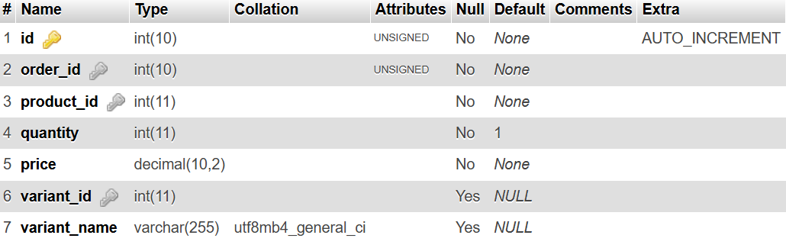

### password_reset

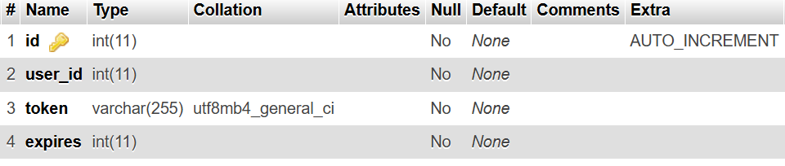

### payments

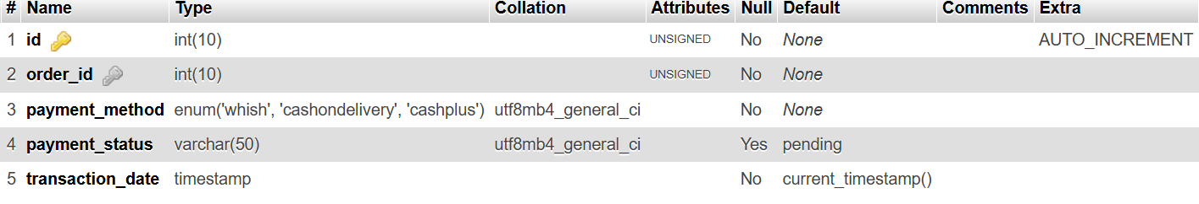

### products_main

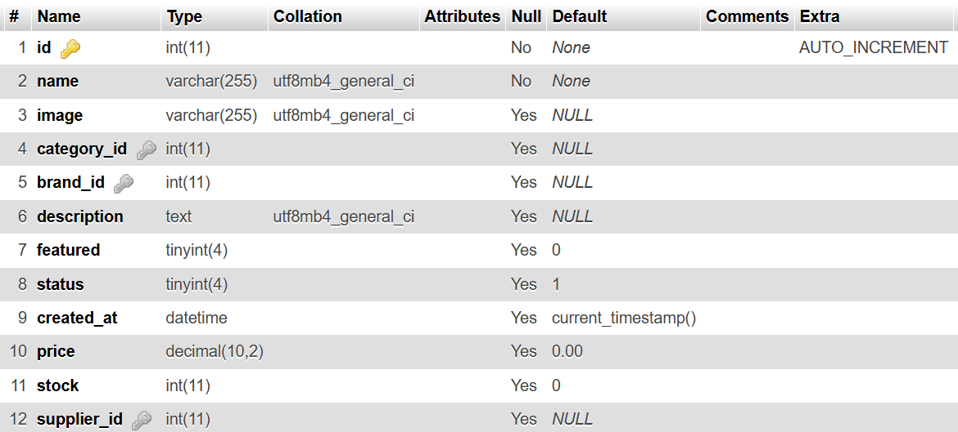

### product_discounts

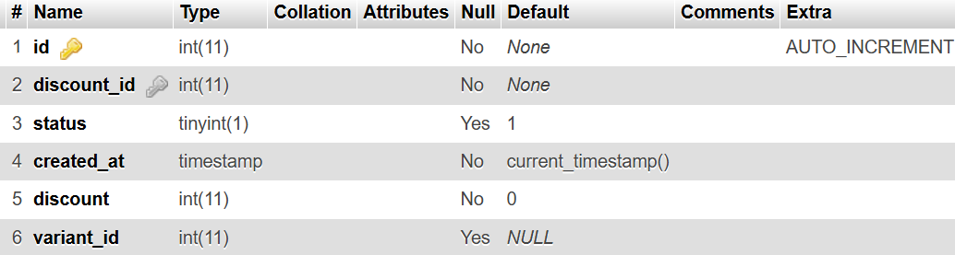

### product_images

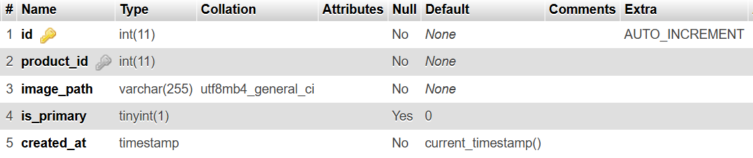

### product_variants

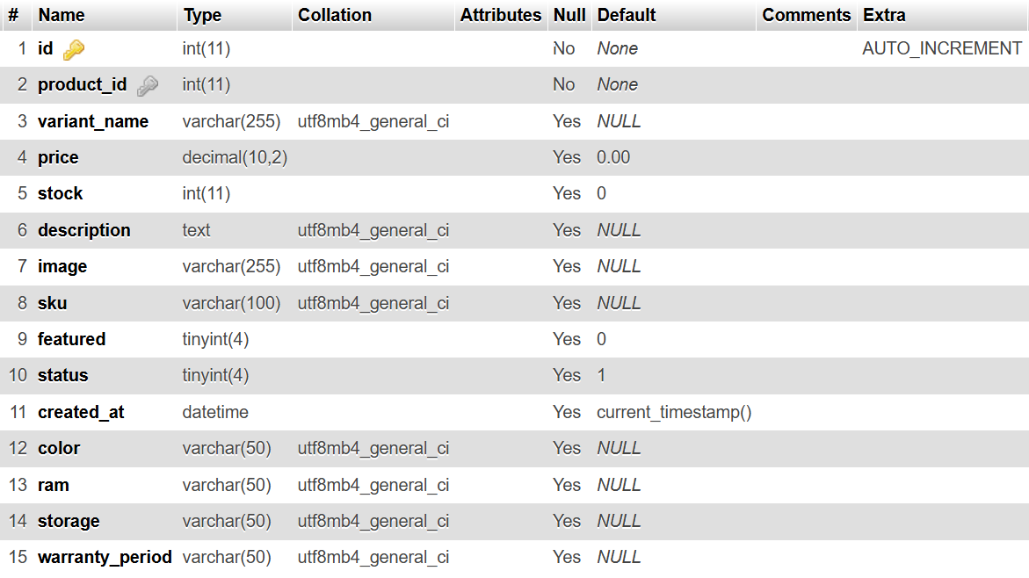

### reviews

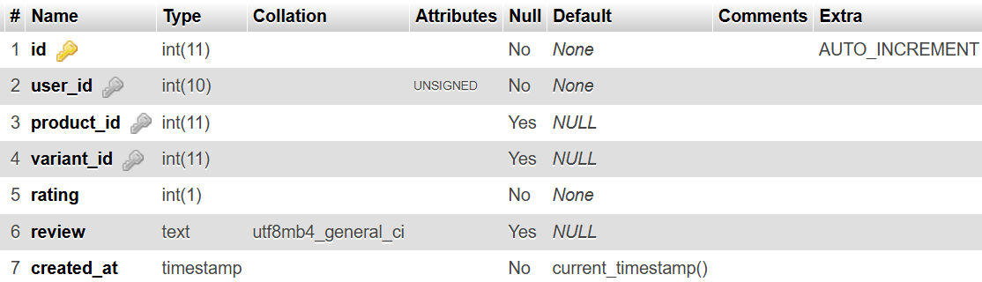

### suppliers

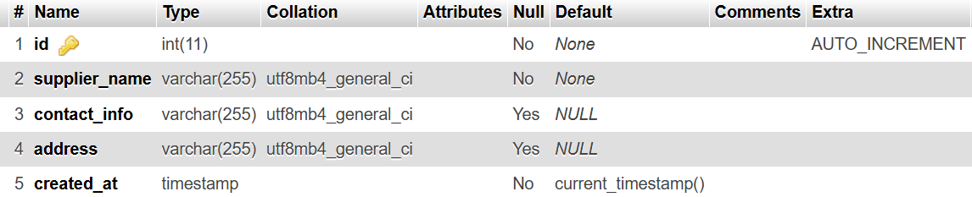

### wishlists

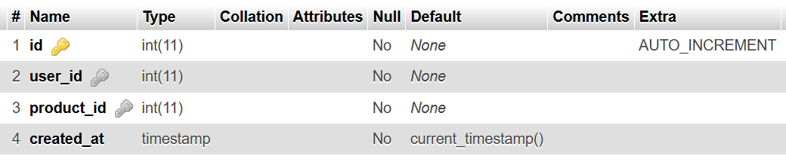

**Relational Diagram:**

This is where the junction tables are formed to drop many to many relations (already explained in ERD part)

* The users table acts as the **parent entity** for Customer, Deliveries and Admin.

These relationships ensure that data flows securely and efficiently between different components of the system.

# Chapter 4

This chapter describes the whole view of our website, it shows the design of my project in addition to stating the main role of each page or button.

## Implementation:

## 4.1 - Introduction:

This chapter illustrates the implemented features and structure of the Class&Tech platform. It provides a detailed walkthrough of the system's main pages, functionalities, and how each component contributes to solving the identified problem. Screenshots are included to visually represent the user interface and workflow.

## 4.2 - Project’s Parts:

### 4.2.1-Home Page:

* The Home Page represents the main public-facing entry point of the **Class&Tech Mobile&Technology Store platform**. It is designed to be visually engaging, informative, and easy to navigate for both **guest users** and **authenticated users**. The page provides quick access to featured products, ongoing discounts, customer reviews, and essential navigation components that guide users throughout the platform.
* The Home Page plays a critical role in shaping the first impression of the system, highlighting promotional content and encouraging user interaction while maintaining a clean and user-friendly interface.

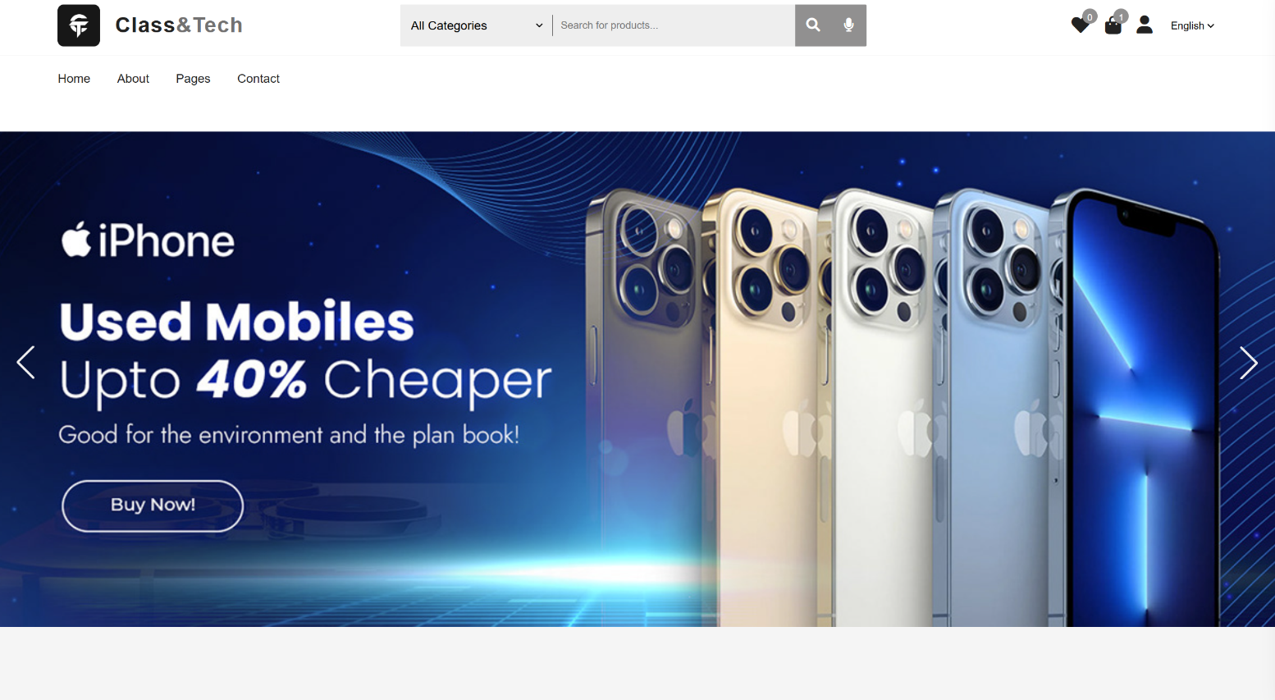

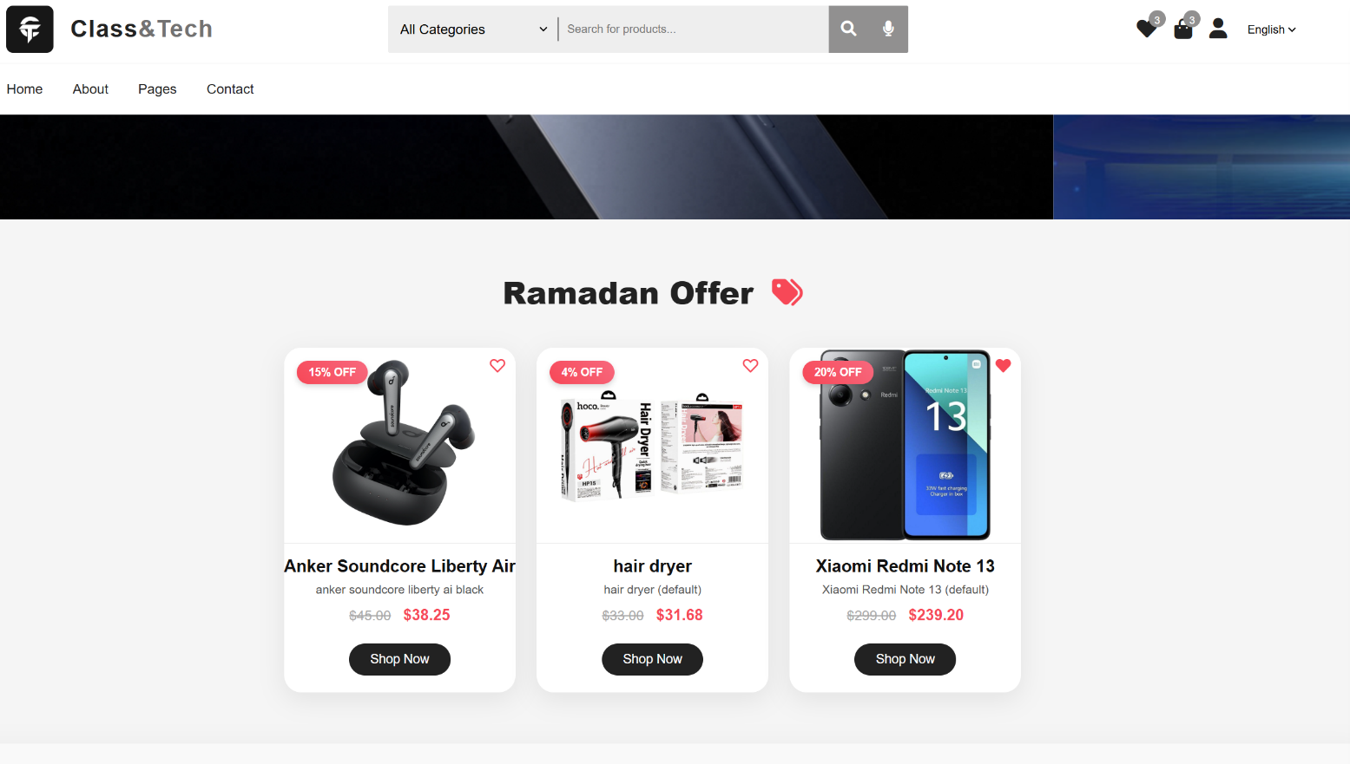

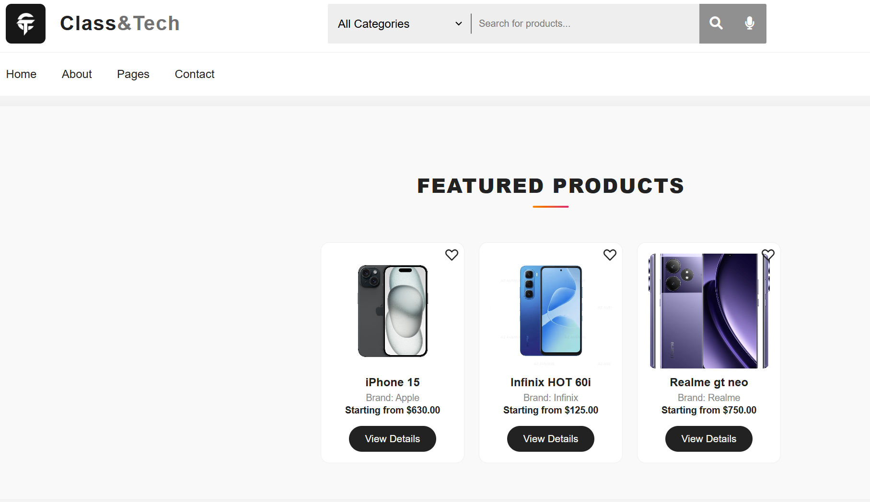

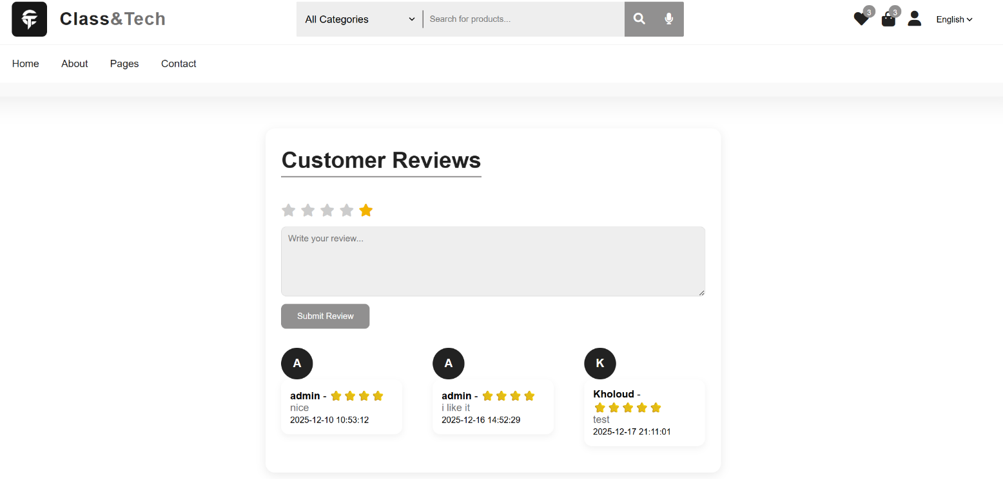

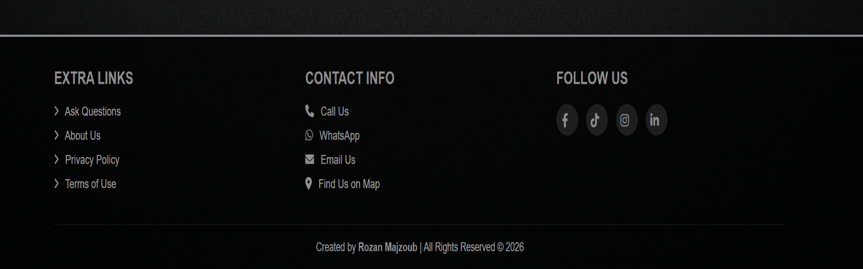

*Figure 3: Home page (Full page from Header to Footer)*

## Header Section

The header section appears at the top of the Home Page and remains consistent across the platform. It serves as the primary navigation and interaction hub for users.

### Logo and Branding

The header includes the **Class&Tech logo and name**, which also functions as a clickable link redirecting users back to the Home Page. This reinforces brand identity and provides a convenient navigation shortcut.

## Search and Category Navigation Functionality

### Category Selection (All Categories)

The **All-Categories** dropdown menu allows users to filter products based on predefined product categories available in the Class & Tech store. These categories typically include mobile phones, accessories, laptops, tablets, and other technology-related items managed by the administrator.

When a user selects a specific category from the dropdown menu, the system limits the search scope to products belonging only to that category. If no category is selected, the system defaults to **All Categories**, meaning the search will include every product available on the platform. This feature improves search precision and enhances user experience by reducing irrelevant results.

The category list is dynamically retrieved from the database, ensuring that only active and available categories are displayed. This allows administrators to add, remove, or disable categories without modifying the front-end code.

**Text-Based Product Search**

The text-based search functionality enables users to search for products using keywords such as product name, model, or brand. When a user enters a search term and submits the form, the system processes the request and displays matching products on the products page.

This feature helps users quickly locate specific items, especially when the store contains many products. Input validation is applied to prevent empty or invalid searches, ensuring meaningful search results.

### Voice Search Functionality

The Home Page includes a **voice search feature**, represented by a microphone icon within the search bar. This functionality allows users to search for products using spoken input instead of typing.

When the microphone icon is activated, the system listens for the user’s voice input and converts it into text using browser-based speech recognition technology. The recognized text is then automatically inserted into the search field and processed as a standard search query.

Voice search improves accessibility for users with physical limitations and enhances usability on mobile devices. It also provides a modern and interactive search experience that aligns with current e-commerce trends.

### Integration Between Search and Categories

The search system is designed to work in combination with the category filter. Users can perform a keyword search within a selected category, allowing for highly targeted product discovery. This integrated approach reduces navigation time and enhances overall platform efficiency.

**Usability and User Experience Considerations**

The placement of the search bar and category selector in the header ensures constant visibility and accessibility across all pages. By combining category filtering, text search, and voice input, the platform caters to different user preferences and browsing behaviors.

These features collectively contribute to a more inclusive, efficient, and user-friendly shopping experience.

### Wishlist Icon

The Wishlist icon (heart symbol) allows users to save products for future reference. A badge counter is displayed on the icon to indicate the number of items currently added to the Wishlist.

* For logged-in users, the Wishlist count is retrieved from the database.
* For guest users, the Wishlist count is managed temporarily through session storage.

Clicking the wishlists icon redirects users to the Wishlist page or to the login page if authentication is required.

### Cart Icon

The cart icon displays the total number of items added to the shopping cart. When clicked, it toggles a **sidebar cart**, allowing users to view cart items dynamically without navigating away from the current page.  
The cart badge reflects the total quantity of items rather than the number of products, providing accurate cart information immediately.

### User Account Icon

The user icon provides access to account-related actions:

* Logged-in users can access their **Profile**, **Admin Dashboard** (if applicable), or **Logout**.
* Guest users are given options to **Login** or **Sign Up**.

This dropdown-based interaction ensures a clean interface while maintaining easy access to account features.

### Language Switcher

A language selector is available to support multilingual functionality, enhancing accessibility for a broader user base.

## Navigation Bar

The navigation bar is located below the main header and includes links to:

* Home
* About
* Pages
* Contact (WhatsApp integration)

This section enables smooth navigation and improves overall user experience.

## Hero Section (Image Slider)

The Hero Section is displayed immediately after the header and uses a **sliding image banner** to capture user attention.  
This section visually represents the brand and promotes the store’s identity through high-quality images.

The slider automatically transitions between images and includes navigation arrows, allowing users to manually browse through slides. This dynamic element enhances visual appeal and engagement.

## Discounts Section

The Discounts Section displays active promotions and special offers available in the store.  
Discount data is dynamically loaded from the database using asynchronous techniques, ensuring real-time updates without reloading the page.

Each discount is presented in a visually structured layout, drawing attention to limited-time offers and encouraging purchases. This section plays an important role in boosting sales and highlighting promotional campaigns.

## Featured Products Section

The Featured Products section showcases a curated selection of products marked as “featured” by the administrator. These products are typically high-demand or promotional items.

Each product card includes:

Product image

Product name

Brand name

Starting price (discount-aware)

Wishlist icon

Link to product details page

Only active products with available variants are displayed. This ensures that users see valid and purchasable items, improving trust and reliability.

## Reviews Section

The Reviews Section allows customers to view and submit feedback about their experience with the store.

### Review Submission

Only **authenticated users** are allowed to submit reviews. If a guest user attempts to leave a review, they are prompted to log in first. This ensures authenticity and prevents spam.

Logged-in users can:

* Select a star rating
* Write a textual review
* Submit the review through a secure form

### Review Display

Submitted reviews are displayed dynamically below the form, allowing visitors to read real customer opinions. This increases transparency and builds trust with potential customers.

## ****Footer Functionality&Workflow****

The footer is displayed consistently at the bottom of every page of the Class & Tech platform, including the Home Page, Products Page, and Product Details Page. It serves both **navigational** and **informational** purposes, providing users with quick access to important pages, contact options, and social media connections.

**1. Quick Links Section:**  
• The footer contains a set of **quick links** such as **FAQ, About, Privacy Policy, and Terms of Use**.  
• Each link is **clickable** and directs the user to the corresponding page within the platform:

* **FAQ**: Opens a page where common customer questions are answered.
* **About**: Provides information about the store, its mission, and team.
* **Privacy Policy**: Opens a page explaining how user data is collected, stored, and protected.
* **Terms of Use**: Directs users to the legal terms governing the use of the platform.  
  • These links improve navigation, allowing users to access relevant information without returning to the main menu. They also reinforce **transparency and trustworthiness** by making legal and informational pages easily accessible.

**2. Contact Information Section:**  
• The footer displays **multiple contact options** for the store, all of which are **interactive and clickable**:

* **Phone Number**: Clicking the phone number initiates a call directly on devices that support telephony (mobile phones or VoIP applications).
* **WhatsApp Link**: Clicking the WhatsApp number opens a chat window with the store in the WhatsApp application or web interface. The system can also pre-fill a message like “Hello, I would like to inquire about…” to make communication easier for the user.
* **Email Address**: Clicking the email opens the default mail client on the user’s device with the recipient field pre-filled, allowing the user to compose and send a message to the store instantly.
* **Location / Map Link**: Clicking the store address opens the location in **Google Maps or the device’s map application**, enabling users to get directions, view the exact location, or explore nearby landmarks.

**3. Social Media Links:**  
• The footer contains icons linking to the store’s **social media profiles** (for example, Facebook, Instagram, Twitter, LinkedIn, or TikTok).  
• Each social media icon is **clickable** and opens the corresponding platform in a new browser tab, allowing users to follow, share, or engage with the store’s content.  
• This provides an additional layer of **brand engagement** and allows the store to reach customers outside the website itself.

**4. Copyright&Author Information:**  
• The footer includes **copyright text**, indicating the store’s ownership of the website content and protecting intellectual property.  
• It may also include **author information**, recognizing the developer or company that created the platform.  
• This section reinforces **professional credibility** and assures users that the platform is officially maintained.

**5. Design&User Experience Considerations:**  
• The footer is **visible on all pages** and often uses a background color or design that differentiates it from the main content while maintaining accessibility.  
• All links use standard **hover effects and clickable cues** (like underlines or color changes) to indicate interactivity.  
• Contact links are formatted for **device compatibility** (phone links work on mobile, map links work with map apps, email links open the mail client).  
• This combination of features ensures that the footer is **both functional and informative**, allowing users to navigate, contact, or engage with the store quickly and efficiently from any page.

## Overall, Home Page Experience

The Home Page of Class&Tech combines functionality, aesthetics, and usability to deliver a professional e-commerce experience. By integrating dynamic content such as sliders, discounts, featured products, and reviews with intuitive navigation and account controls, the page effectively serves both marketing and operational goals of the platform.

### 4.2.2-Signup Page:

The **Signup Page** allows new users to register on the platform as acustomer. The user is asked to add few details to register other details can be managed from Profile. The layout is responsive and simple, focusing on clarity and usability.

*Figure 4: Signup Page*

### Customer Signup Form

* The customer registration form is the primary interface through which new users create their accounts on the Class & Tech platform. The form is designed to be clear, user-friendly, and secure, collecting all the necessary information to build a complete customer profile. The main fields in the registration form include **Username**, **Email**, and **Password with Confirm Password**. The username allows the system to identify the user easily and provides a personalized experience, while the email serves both as a unique identifier and a communication channel for account-related notifications. The password fields ensure account security, with users required to enter their chosen password twice to confirm accuracy and reduce errors. This information is essential not only to create the account but also to assess the eligibility of the user for accessing platform features and to maintain secure login procedures.
* After submitting the registration form, the platform initiates a **post-submission verification process**. A verification code or link is automatically sent to the email address provided by the user. The email contains instructions for completing account verification. When the user clicks the verification link, the system confirms their email address and redirects them to the login page. This ensures that the account is associated with a valid, active email and adds a layer of security to prevent fake or unauthorized account creation.
* The platform implements **comprehensive validation mechanisms** to ensure that the submitted data is correct and secure. Validation occurs both on the client side and the server side. Client-side validation provides immediate feedback to the user, checking that required fields are completed, that the email is in the correct format, and that the password meets strength requirements. Server-side validation provides a second layer of security, verifying that the email is unique, that passwords match, and that no malicious data is submitted. This dual-layer validation ensures data integrity and helps prevent account creation errors or security vulnerabilities.
* Overall, the Signup Page is a crucial entry point to the system, combining **ease of use with secure data collection**. By adapting the form dynamically based on the selected role, the platform provides a **streamlined experience** tailored to the user’s needs. This careful design ensures that new customers can quickly register, verify their account, and gain access to the platform while maintaining a high level of security and accuracy in the information collected.

### 4.2.3-Login Page:

After completing the signup form, users are redirected to the login page after clicking the link for verification. This step ensures that the email address provided during registration is valid and accessible.

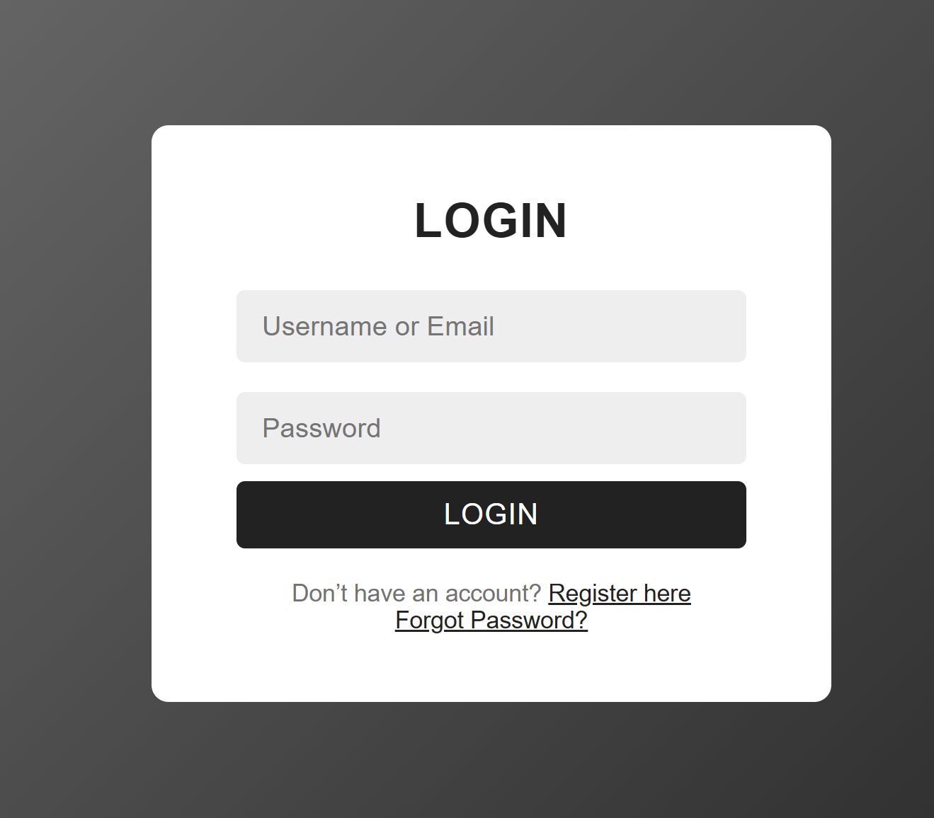

*Figure 5: Login page*

### Components and Functionality

* The login section of the platform allows users to access their personal accounts securely and conveniently. Users can log in using **two options: either their username or their email address**. This dual option is designed to accommodate different user preferences. Some users find their username easier to remember, especially if their email is long, complex, or used for multiple services. Others may prefer using their email for consistency across platforms. The system validates whichever input the user provides and identifies the account associated with it.
* The password field is a secure textbox where the user enters the password they created during registration. The system ensures that the password is encrypted and compared securely with the stored credentials in the database. This ensures that unauthorized users cannot access accounts and that the authentication process remains confidential.
* If the user forgets their password, the login screen provides a **forgot password link**. Clicking this link redirects the user to a separate password recovery page. On this page, the user enters the email address associated with their account. The system then generates a **secure password reset link** and sends it to the user’s email. This link allows the user to create a new password. Once the password is reset, the user can return to the login page and access their account with the updated credentials. This feature ensures that users can regain access to their accounts without needing to contact support manually, while still maintaining a high level of security.
* Overall, the login components and functionality are designed to provide a **flexible, user-friendly, and secure access point** to the platform. The combination of username/email login, secure password entry, and the password recovery process ensures that all users can log in with ease, maintain account security, and recover access quickly if needed.

### 4.2.4-Forgot password Page:

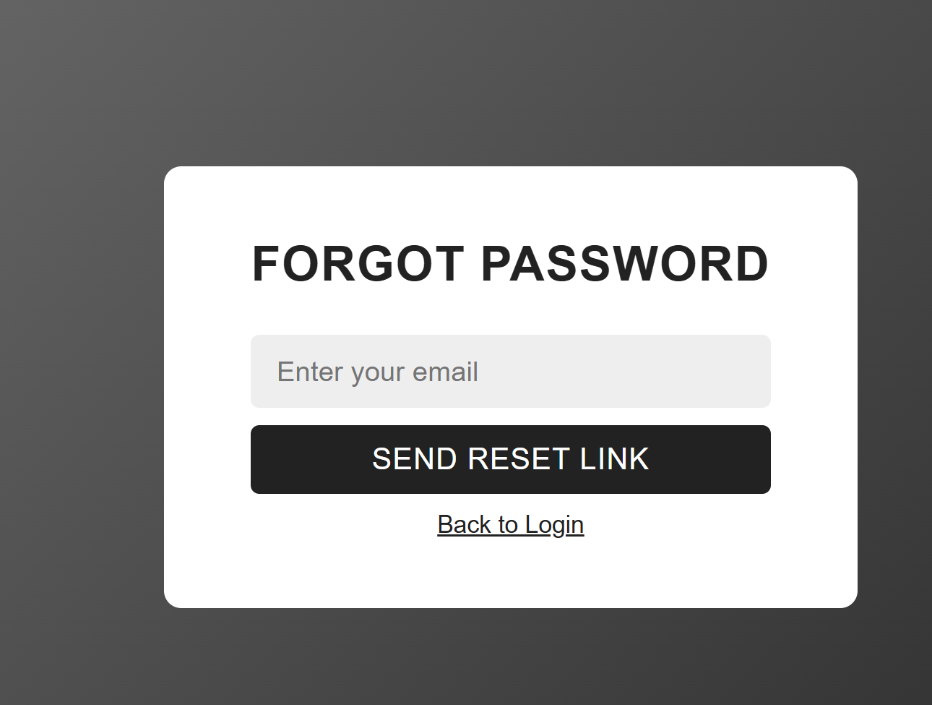

*Figure 6: Forgot password page*

### Components and Functionality:

* The Reset Password module is designed to allow users to securely recover access to their accounts in case they forget their login credentials. This feature enhances system usability while maintaining security standards.
* The reset password interface includes an **email textbox**, where the user is required to enter the email address that was previously registered in the system. This ensures that password recovery requests are associated with valid user accounts. Once the email is entered, the user clicks on the **“Send Reset Link”** button to initiate the password recovery process.
* After submitting the request, the system verifies the existence of the email address in the database. If the email is valid, the system generates a unique and secure reset token and sends a **password reset link** to the user’s registered email address. This link is time-limited to prevent unauthorized access and enhance security.
* When the user opens the email and clicks on the reset link, they are redirected to the **Reset Password screen**. This screen allows the user to enter a new password and confirm it by retyping the same password. The system validates the password strength and ensures that both password fields match before allowing submission.
* Once the new password is successfully updated in the database, the system displays a confirmation message and automatically redirects the user back to the **login page**. The user can then log in using the newly updated password. This entire process is illustrated in **Figure 7: Reset Password Page**.
* This module ensures a secure, user-friendly, and efficient method for account recovery, contributing to overall system reliability and user satisfaction.

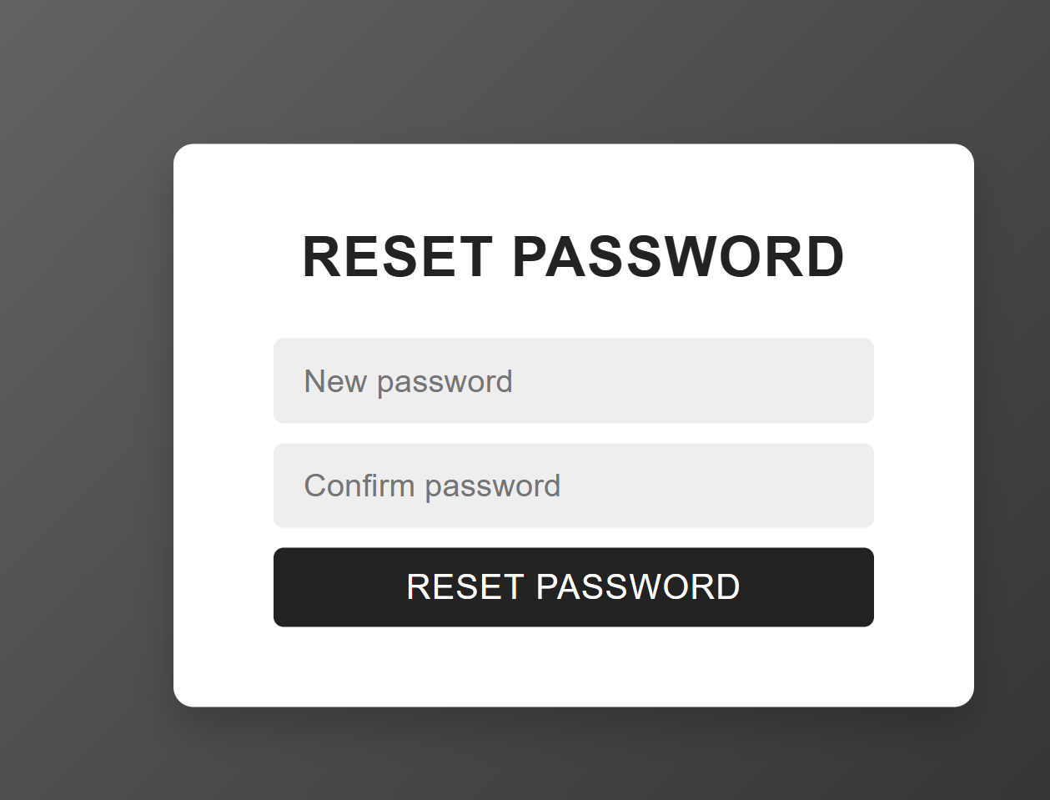

*Figure 7: reset password page*

### 4.2.5-About Page:

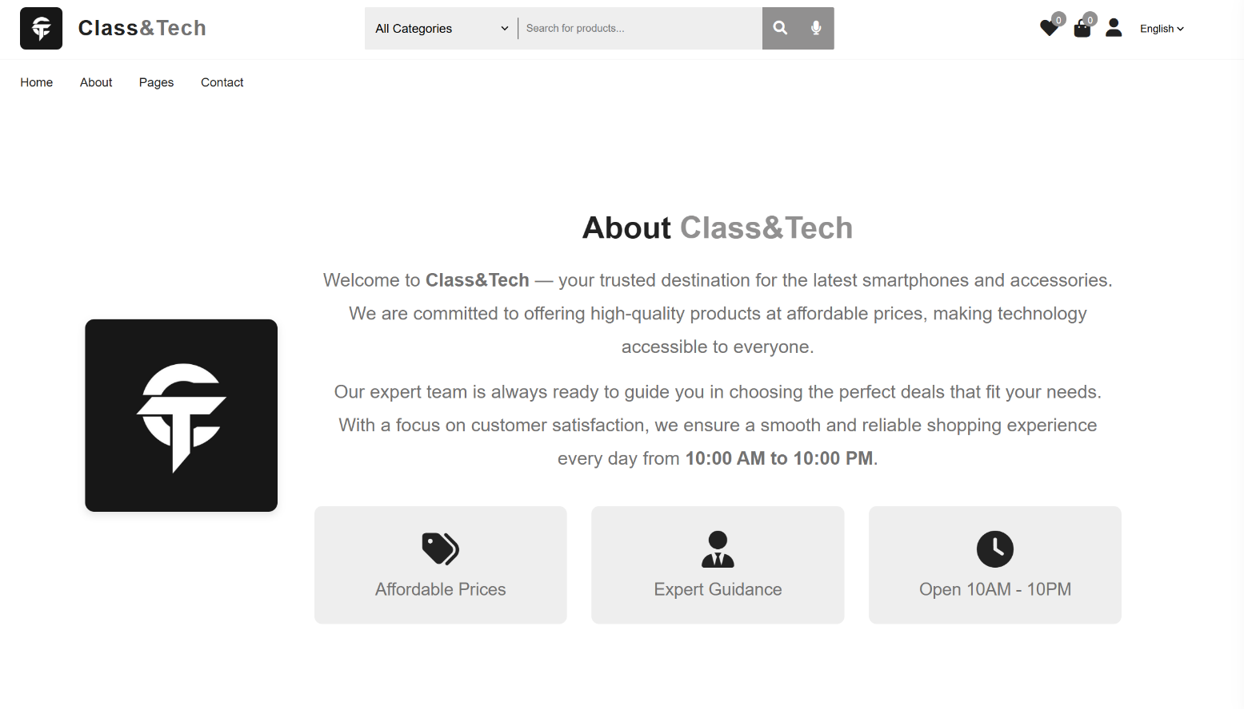

*Figure 8: About page*

**Functionality – Store Information Page**

* The Store Information page is designed to provide users with essential details about the Class&Tech Mobile Store. This page serves as an informational section where customers can learn more about the store, its mission, and its commitment to providing high-quality mobile and technology products.
* One of the main functionalities of this page is to display the **store’s opening hours**, allowing customers to know when the physical store is open and available for in-person visits. This helps customers plan their visits more effectively and creates transparency between the business and its customers.
* Although this page does not offer interactive features such as purchasing or order management, it plays an important supporting role within the system. By presenting accurate store information, the page helps build customer trust and strengthens the store’s professional image. It also demonstrates the effort made to integrate the physical store with its online presence.
* Overall, the Store Information page enhances the credibility of the platform and supports the store’s goal of providing a complete and accessible experience, both online and offline. While its functionality is simpler compared to other system modules, it remains an essential component in establishing communication and reliability with customers.

### 4.2.6-Pages Page:

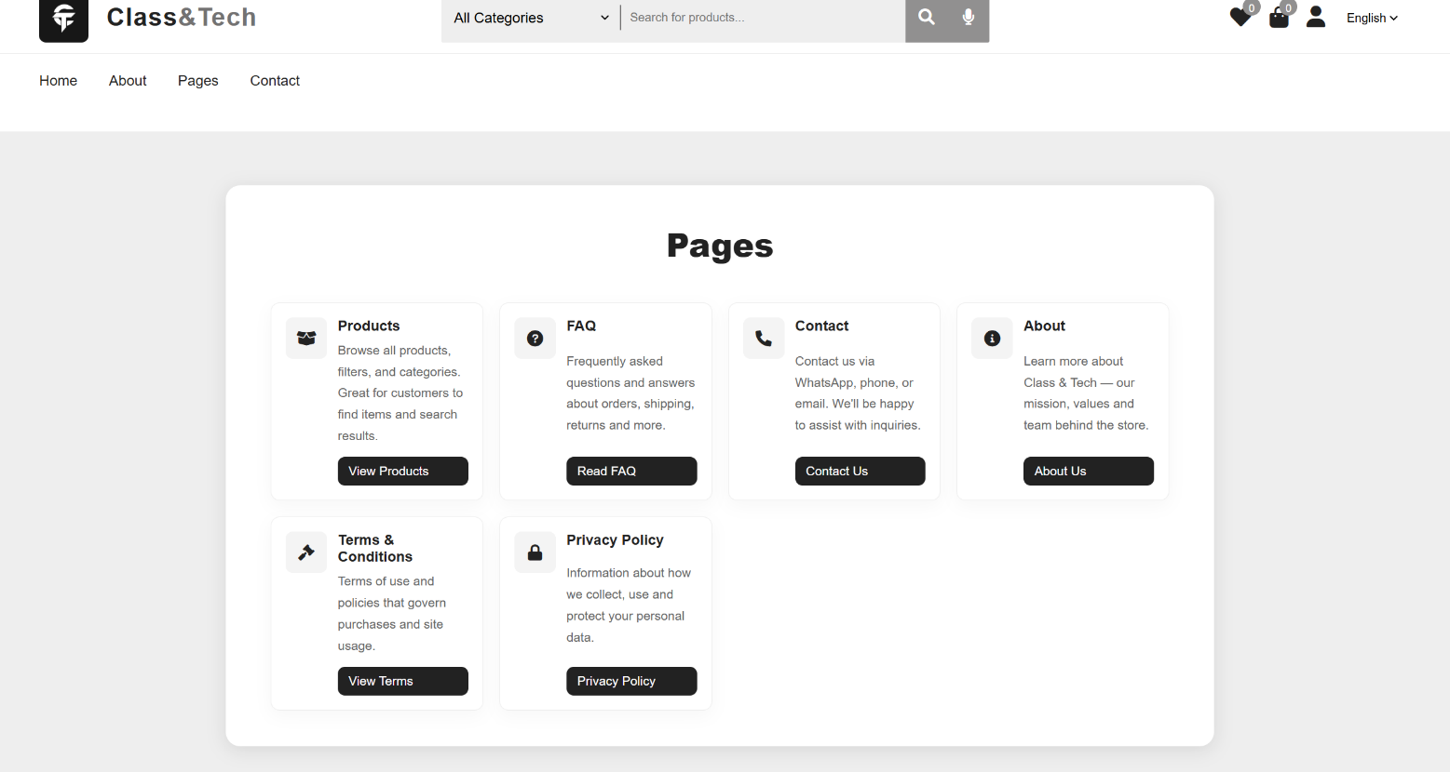

*Figure 9: Pages page*

### Components and Functionality – Main Navigation Pages

* This section describes the main pages produced by the system that form the core navigation structure of the Class & Tech Mobile Store website. These pages allow users to easily access essential information and services while ensuring a smooth and organized browsing experience.
* The **Products Page** displays all mobile phones, accessories, and technology products available on the website. This page allows customers to browse products, view images and specifications, compare prices, and check availability. It acts as the primary entry point for customers interested in purchasing items and is one of the most frequently accessed pages on the platform.
* The **Frequently Asked Questions (FAQ) Page** provides answers to common questions that customers may have regarding products, ordering procedures, delivery policies, payments, and returns. By addressing these questions in advance, the page helps customers feel more secure and confident when using the system, while also reducing the number of support inquiries directed to administrators.
* The **Contact Page** includes a direct contact link that allows customers to communicate instantly with the store administrator. When the customer clicks on the contact option, the system redirects them directly to **WhatsApp**, opening a chat with the administrator’s registered number. This feature enables quick and convenient communication, improving customer support and response time.
* The **Privacy Policy Page** outlines how the system collects, stores, uses, and protects user personal data. This page is essential for transparency and legal compliance, as it informs users about data privacy practices, including account information, order details, and communication data. It also helps build trust by assuring users that their information is handled securely.
* The **Terms and Conditions Page** defines the rules and policies that govern the use of the website. It covers topics such as user responsibilities, purchase conditions, refund policies, delivery terms, and system usage guidelines. This page protects both the business and the users by clearly stating the rights and obligations of each party.
* Together, these pages form a structured and informative navigation system that enhances usability, builds customer trust, and supports the overall professionalism of the Class&Tech Mobile Store platform.

### 4.2.7-Wishlist Page:

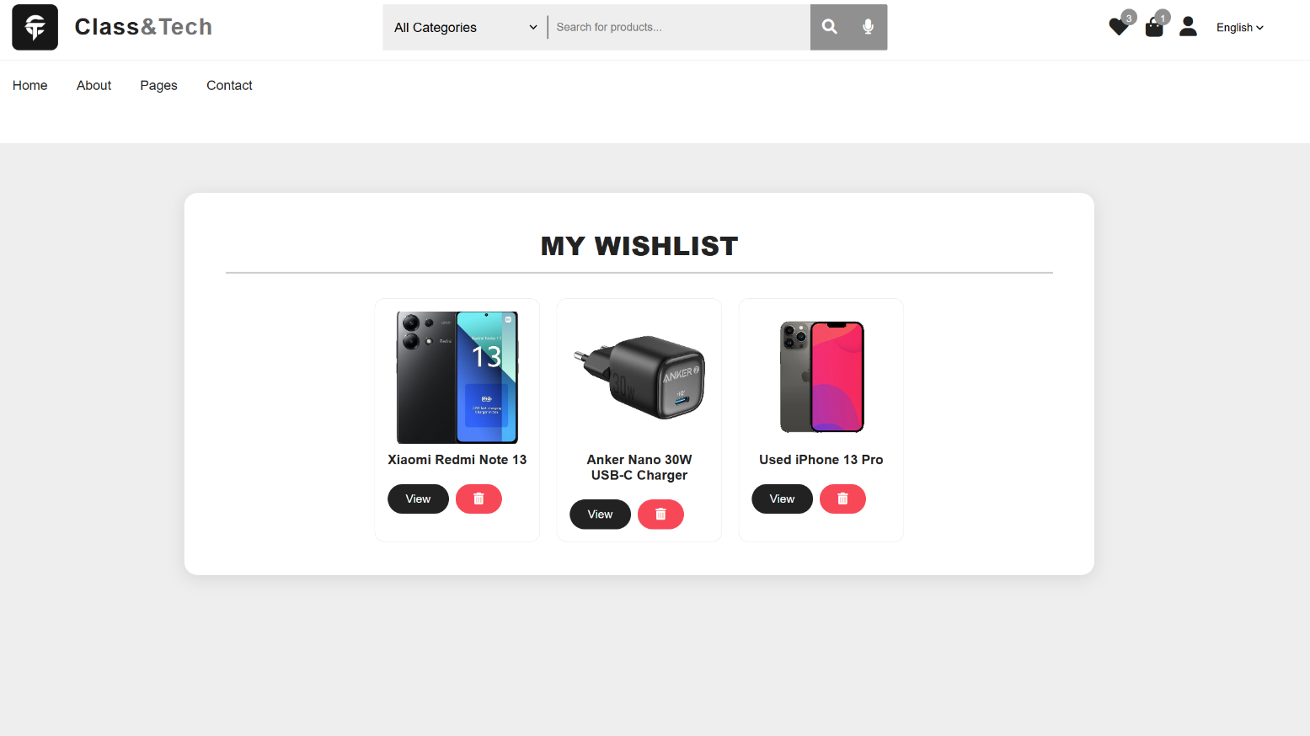

*Figure 10: Wishlist page*

### Components and Functionality – Wishlist Feature

* The Wishlist feature is designed to allow customers to save products they are interested in for future purchase. This functionality enhances user experience by providing flexibility and convenience, especially for customers who wish to compare products or delay purchasing decisions.
* Each product displayed on the store interface includes a **heart icon** positioned at the top-right corner of the product card. When a customer clicks on this heart icon, the selected product is instantly added to the customer’s Wishlist. This action allows users to mark products they like without adding them directly to the shopping cart.
* As products are added to the Wishlist, the system dynamically updates the **Wishlist badge counter** displayed on the heart icon located in the header of the website. The badge number increases according to the number of products saved, providing a visual indication of how many items the customer has stored for later review.
* When the customer clicks on the heart icon in the header, the system redirects them to the **Wishlist Page**. This page displays all products that have been previously saved by the customer. From this page, the customer can view detailed information about each product, such as images, descriptions, and prices. Additionally, customers can remove any product from the Wishlist by clicking on the **garbage (delete) icon**, allowing them to manage their saved items easily.
* Overall, the Wishlist feature improves customer engagement and supports better purchasing decisions by enabling users to organize and revisit preferred products efficiently. It also contributes to increased return visits and potential conversions for the store.

### 4.2.8-SideBar Cart:

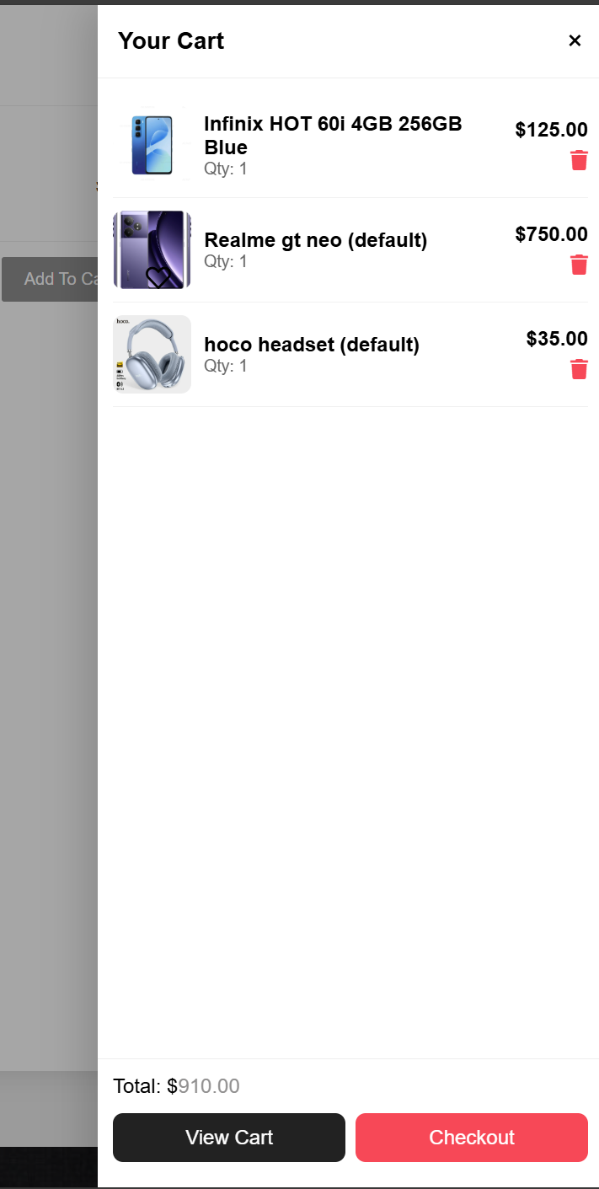

*Figure 11: Sidebar Cart*

### Components and Functionality – Sidebar Cart

* The Sidebar Cart feature is a dynamic shopping cart component commonly used in modern e-commerce platforms. It allows customers to manage their selected products without being redirected to a separate page, thereby enhancing usability and maintaining a smooth browsing experience.
* When a customer clicks the **“Add to Cart”** button on any product, the selected item is immediately added to the cart. At the same time, the **sidebar cart automatically opens**, allowing the customer to instantly view the added product. This real-time interaction provides immediate feedback and confirms that the product has been successfully added.
* The sidebar cart displays a list of all selected products, including basic details such as product name, image, price, and quantity. Customers are given the option to **remove items directly from the sidebar** if they change their minds, making cart management quick and convenient.
* At the bottom of the sidebar cart, the **total amount** is calculated and displayed dynamically based on the products and quantities selected. This allows customers to continuously monitor how much they need to pay before proceeding further, helping them make informed purchasing decisions.
* For more detailed cart management, customers can click on the **“View Cart”** button, which redirects them to the main cart page. On this page, customers can update product quantities, view the **unit price** of each product, and see the **subtotal** calculated when more than one unit of a product is selected.
* Additionally, the sidebar cart includes a **“Checkout”** button that allows customers to proceed directly to the checkout process. By clicking this button, customers are taken to the checkout page where they can confirm their order and place the purchase. This streamlined process reduces unnecessary steps and improves overall conversion rates.
* Overall, the Sidebar Cart feature enhances user experience by providing flexibility, transparency, and efficiency in managing shopping activities throughout the platform.

### 4.2.9-Cart page&Checkout:

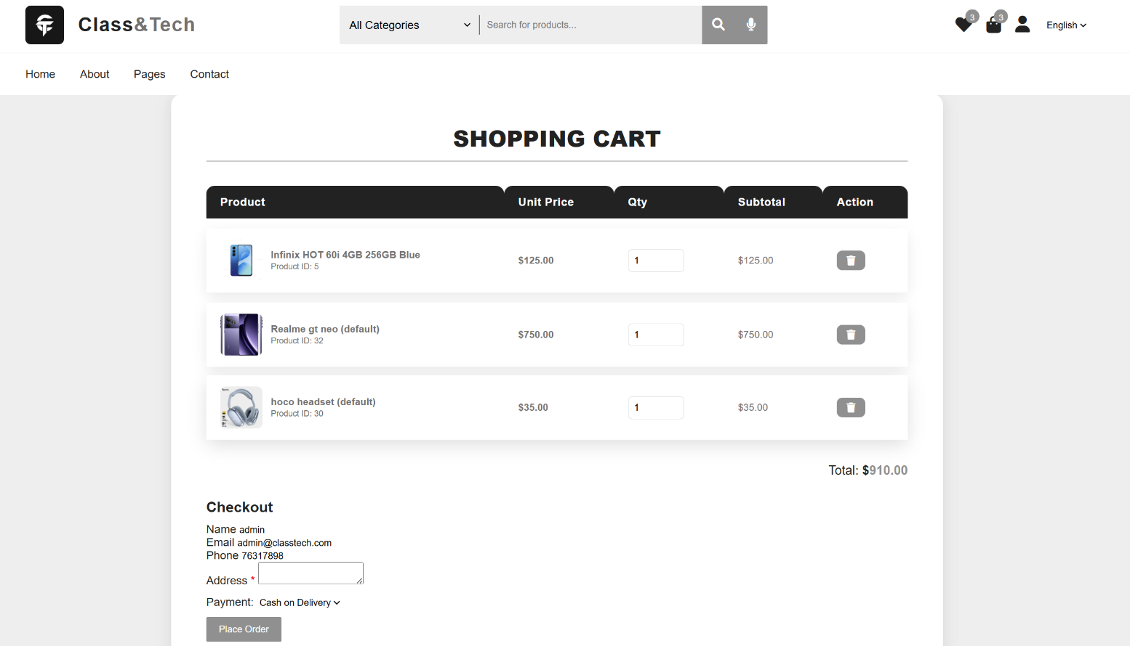

*Figure 12: Cart Page&Checkout*

### Components and Functionality – Cart Page

* The Cart Page provides customers with a detailed overview of the products they intend to purchase. Unlike the sidebar cart, which offers quick access and basic management, the cart page allows full control over cart items and quantities before proceeding to checkout.
* On this page, all selected products are displayed in a structured table format that includes product images, product names, unit prices, selected quantities, and subtotals. Customers can **increase or decrease the quantity** of each product directly from the cart page. When the quantity of a product is modified, the system automatically recalculates the subtotal for that item as well as the overall cart total.
* Customers also have the option to **remove products** entirely from the cart if they decide not to purchase them. This flexibility allows users to review and adjust their selections carefully before finalizing the order. The cart page continuously displays the updated **total amount**, always ensuring price transparency.
* The Cart Page acts as an important review stage in the purchasing process, helping customers verify their order details and avoid mistakes before proceeding to checkout.

### Components and Functionality – Checkout Page

* The Checkout Page is responsible for collecting and confirming all necessary information required to place an order successfully. This page is designed to minimize user effort while ensuring that all essential data is available for order processing and delivery.
* When a registered customer accesses the checkout page, the system automatically retrieves and displays the user’s information from their profile. This includes personal details such as full name, email address, phone number, and saved delivery address. By pre-filling these fields, the system reduces repetitive data entry and improves user convenience.
* If certain required fields are **not set in the user’s profile**, the system prompts the customer to complete the missing information directly on the checkout page. These fields must be filled in before the order can be placed. Validation mechanisms ensure that all mandatory information is provided and correctly formatted.
* The checkout page also displays a summary of the order, including selected products, quantities, applied discounts, delivery fees (if any), and the final payable amount. This allows customers to review their order one last time before confirmation.

### Order Placement Workflow

* The order placement process begins once the customer confirms the checkout form and submits the order. At this stage, the system performs several validations checks to ensure that all required user information is complete and that the cart contains valid products with available stock.
* Upon successful validation, the system creates a new order record in the database. The order is linked to the customer’s account, and all selected products are stored as order items with their respective quantities and prices. The system then updates the product stock levels to reflect the completed purchase.
* After the order is successfully placed, the system assigns an initial **order status**, such as “Pending” or “Processing,” and generates an order confirmation. The customer is notified of the successful order placement and can view the order details in their order history section.
* This workflow ensures a smooth, secure, and efficient order placement process by combining automatic data retrieval from the user profile with mandatory input validation. It reduces user effort, minimizes errors, and ensures that all necessary information is available for order fulfillment and delivery.

### *4.2.10-User Account icon:*

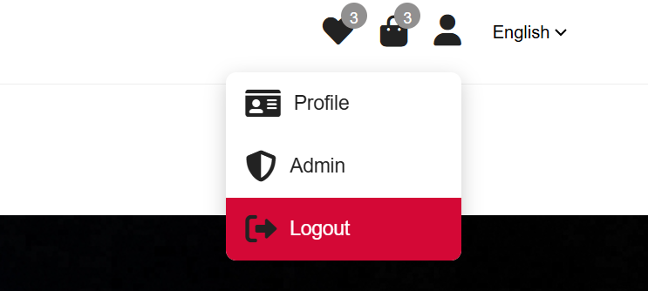

*Figure 13: User icon*

### Components and Functionality – User Account Icon

* The User Account Icon is located at the top section of the website header and serves as the primary access point for account-related actions. This icon is visible only to authenticated users and provides quick access to essential account functions without requiring navigation to separate pages.
* When the user clicks on the user icon, a dropdown menu is displayed containing two main options: **Profile** and **Logout**. This design ensures simplicity and ease of access, allowing users to manage their account efficiently from any page within the platform.
* The **Logout** option allows users to securely exit their account. Upon selection, the system terminates the active session and redirects the user to the login page or homepage. This feature ensures account security, especially when the platform is accessed from shared or public devices.

***4.2.11-Profile page:***

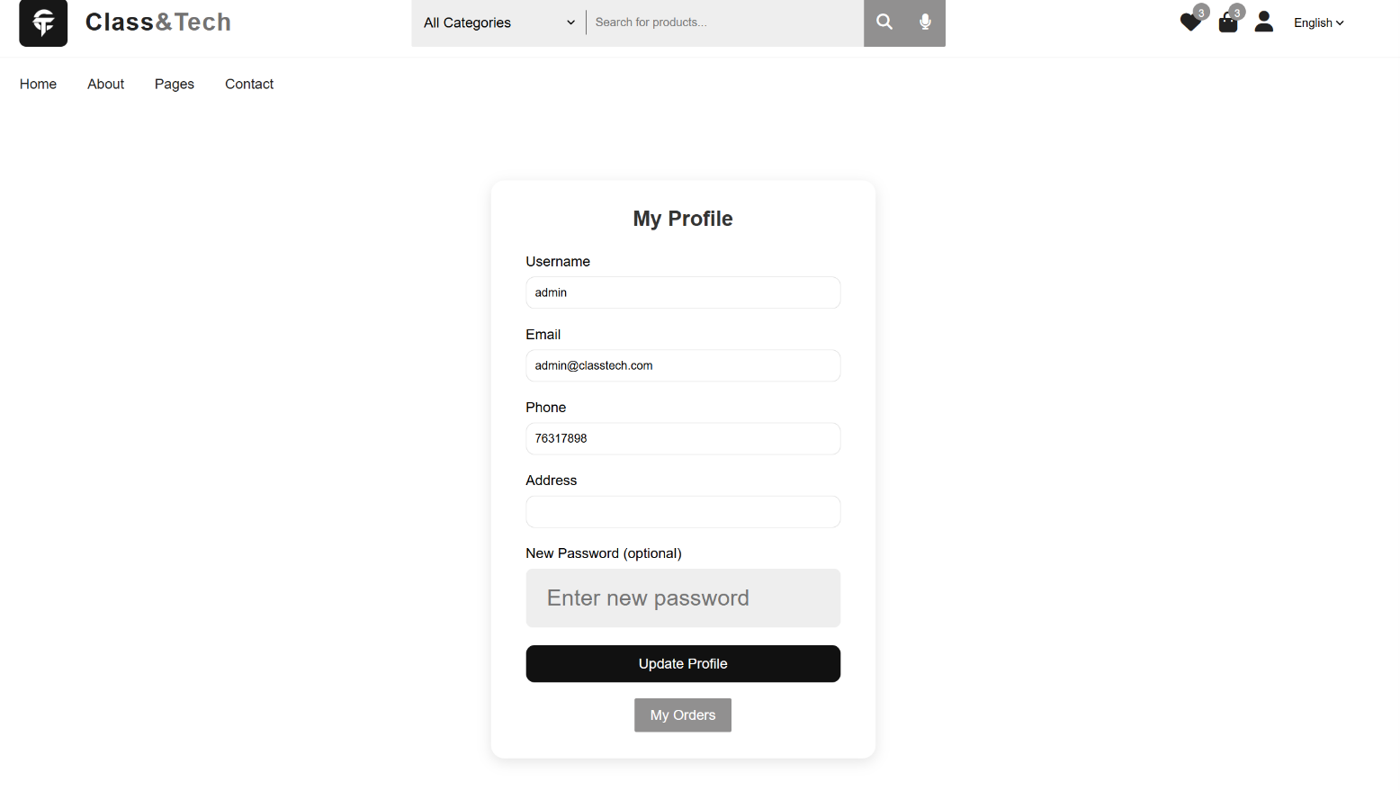

*Figure 14: Profile page*

### Components and Functionality – Profile Page

* The Profile Page allows users to view and manage their personal account information. This page is particularly important because some user details may not be required during the initial registration process but are essential for placing orders and ensuring successful delivery.
* On the profile page, users can update information such as **phone number**, **delivery address**, and other personal details. These fields are stored securely in the database and are later retrieved automatically during the checkout process. By allowing users to set this information in advance, the system reduces friction and speeds up order placement.
* The profile page also allows users to update their login credentials, such as changing their password. Input validation is applied to ensure data accuracy and security. Any updates made on this page are saved in real time and reflected immediately throughout the system.

### 4.2.12-Order History:

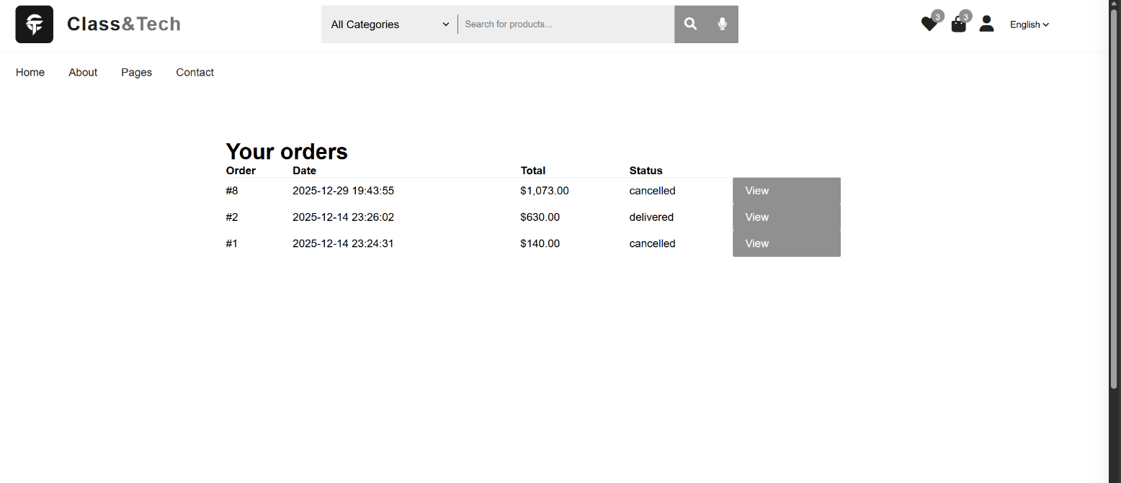

*Figure 15: Order History*

### Components and Functionality – Order History

* The Order History section is accessible through the profile page and provides users with a complete record of all orders they have placed on the platform. Each order entry includes essential details such as order number, order date, total amount, and current order status.
* Users can click on individual orders to view detailed information, including purchased products, quantities, prices, and delivery status. This feature enhances transparency and allows users to track their past and current purchases easily (*Figure 16: Order details).*
* The order history functionality improves user trust by providing clear documentation of transactions and allows customers to reference previous purchases for reordering or support inquiries. It also contributes to a professional and reliable user experience.

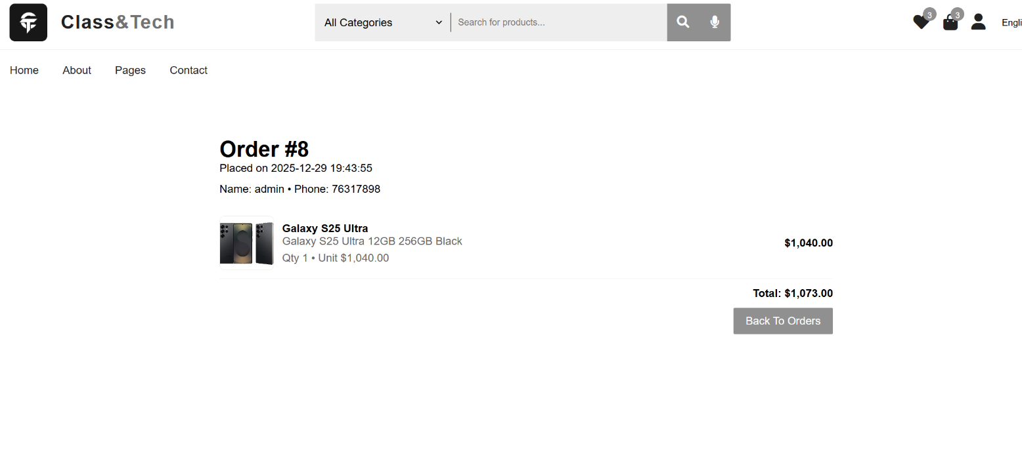

*Figure 16: Order details*

### 4.2.13-Products page:

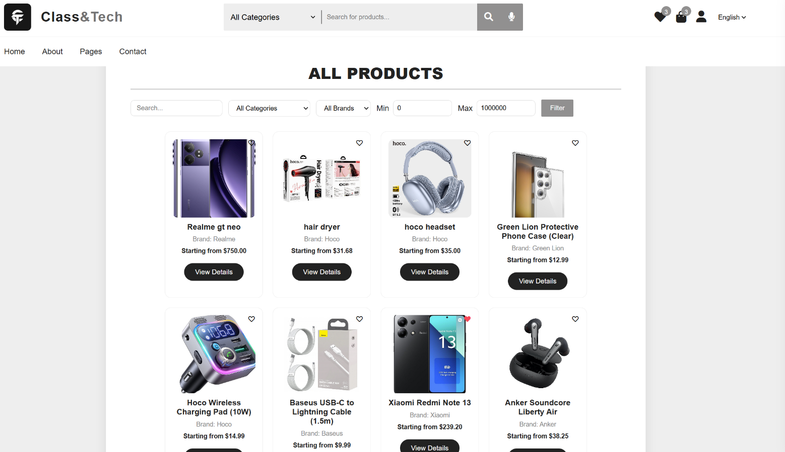

*Figure 17: Products page*

## ****Product Search&Filtering Workflow****

• The product search process begins when a customer interacts with the **search bar** located either on the home page or directly on the Products page. The system listens for user input in the search field and can also receive **search queries via GET parameters** in the URL, allowing the page to maintain state across multiple requests and pagination.

• Before any database query is executed, the system performs **input validation and sanitization**:

The raw search input is trimmed to remove extra whitespace.

It is converted to lowercase to enable **case-insensitive searching**.

All user inputs, including category, brand, and price values, are validated to ensure they are numeric where appropriate and fall within expected ranges. This prevents malicious input and ensures query integrity.

• In addition to the search bar, the system provides **dynamic filters** for the user:

**Category Filter**: Lists all active product categories. Users can select a category to view only products within that category.

**Brand Filter**: Lists all available brands to narrow down products.

**Price Range Filter**: Users can specify minimum and maximum prices to filter products based on affordability or budget constraints.

• After the search term and filters are submitted, the system **constructs a dynamic SQL query** to fetch products from the database:

Only active products and variants are retrieved (status = 1).

The search term is compared against multiple fields: product name, description, brand name, category name, variant name, variant color, RAM, and storage. This ensures a **broad and accurate matching** for customer queries.

The category, brand, and price filters are applied as additional conditions in the query.

A **discount-aware price calculation** is included to ensure that the displayed price reflects any active discounts on product variants.

• The query also performs aggregation to select:

The **minimum price** across all variants of a product as the starting price.

The first available variant ID for linking to the **Product Details page**.

A representative image for display in the product grid.

• Once the query executes successfully, the system fetches the results and prepares the **Products Grid**:

Each product card displays an image, name, brand, starting price, and a **wishlist heart icon**.

If the user is logged in, the system queries the wishlist table to determine which products have already been wished. This information is used to highlight the heart icon (fa-solid if wished, fa-regular if not).

A **“View Details” button** is provided to navigate to the individual product page.

• The system handles **pagination** to manage large product inventories efficiently:

By default, 12 products are displayed per page.

The total number of products matching the search and filters is calculated.

Pagination links are generated dynamically, including all active filters and the search term, to maintain the current view state.

The current page is highlighted visually to guide navigation.

• This workflow also ensures **performance optimization**:

Queries are limited to the products required for the current page using LIMIT and OFFSET.

Aggregate queries and joins are carefully structured to minimize database load, even with complex filtering.

• From the user perspective, this workflow provides a **fluid and interactive experience**:

Users can search, filter, and navigate without losing context.

Products are displayed with clear visuals and relevant metadata.

Wishlist integration allows immediate visual feedback for products already saved.

Price, brand, and category information help users quickly identify suitable products.

• Overall, the **Product Search&Filtering Workflow** ensures that users can locate products efficiently, accurately, and interactively, reducing friction and improving the discoverability of items in the Class & Tech platform.

***4.2.14-Products details page:***

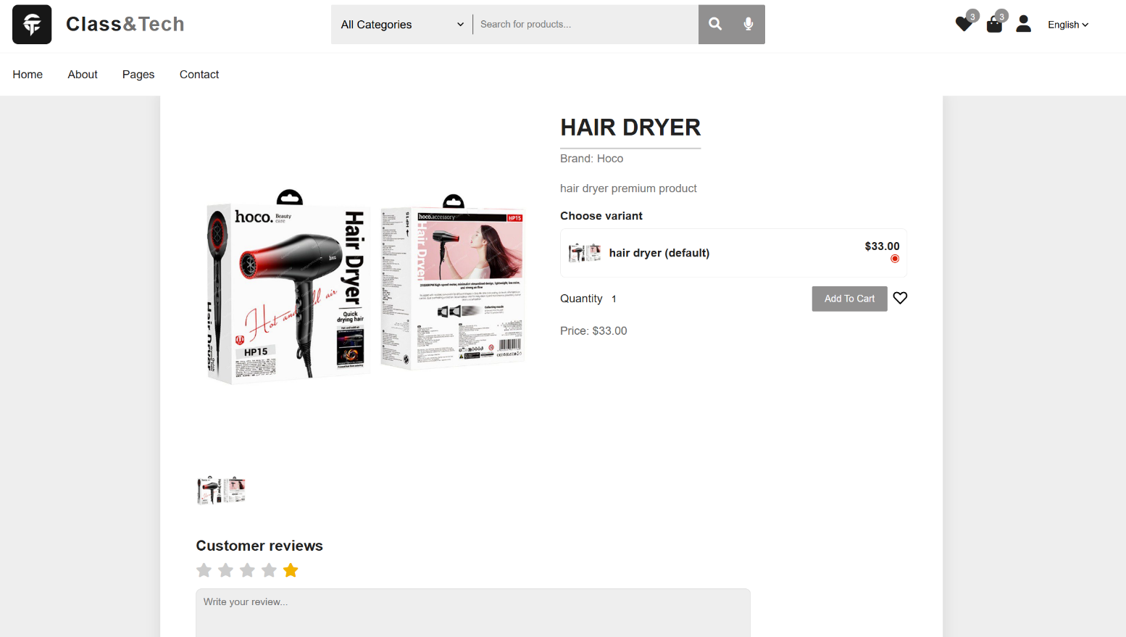

*Figure 18: Products details page*

## ****Product Details Workflow****

When a user selects a product from the search results or products grid, the system redirects to the **Product Details page** using a URL containing the product ID (and optionally the selected variant ID). This ensures that the system loads the precise product requested by the user.

• Upon page load, the system performs **product validation**:

It checks whether the product parameter exists and is numeric.

If the product ID is invalid or not found in the database, the system automatically redirects the user back to the main Products page.

• The system retrieves comprehensive **product information** from the database:

**Product main info**: name, description, brand, category, general price.

**Product variants**: All available variants including variant name, RAM, storage, color, price, and stock levels. Variants are sorted by price or ID to enable intuitive selection.

**Product images**: Multiple images for display in a gallery, including a primary image for initial viewing.

**Product discounts**: Any applicable discounts are considered in price calculations to display correct pricing.

• A **primary image selection logic** determines which image to display prominently:

Main product image if set.

First image from the product_images table.

Variant image if no main or gallery image is present.

Placeholder image if no images are available.

• Users can interact with the **image gallery**:

Clicking on a thumbnail replaces the primary image dynamically.

Images are displayed with a consistent size and aspect ratio to ensure a uniform and visually appealing layout.

Images are normalized to support both local paths (images/<filename>) and absolute URLs.

• **Variant selection and ordering**:

If the product has variants, customers must select a variant before adding it to the cart.

Each variant card displays its own price, stock status, and small thumbnail if available.

Out-of-stock variants are clearly labeled and disabled to prevent ordering errors.

Customers can select a quantity for each product or variant.

If the product has no variants but has a price, it can be added to the cart directly.

• The **Add to Cart** process includes:

AJAX-based submission to prevent page reloads.

Automatic validation of selected variant and quantity against stock levels.

Immediate visual feedback confirming the item has been added to the cart.

• The **Wishlist integration**:

Logged-in users can toggle the Wishlist heart button to add or remove the product.

The button dynamically updates to show current state (fa-solid for wished, fa-regular for not wished).

Wishlist state persisted in the database for future sessions.

• The **reviews section** provides a way for users to submit feedback:

Logged-in users can select a star rating (1-5) and write a textual review.

Guest users are prompted to log in, with redirect back to the product page after login.

Submitted reviews are stored in the database and displayed dynamically for other users.

The system includes basic **front-end validation** to ensure reviews are non-empty and star ratings are numeric.

• **Price display logic**:

For products with variants, the system shows a **price range** (minimum to maximum) to indicate potential cost variations.

For products without variants, the fixed price is displayed prominently.

If no price is set, the system notifies the customer and, for admin users, provides a direct link to manage product pricing.

• **Responsive layout and UI design**:

Flexbox is used to arrange images, variant selections, and product information dynamically.

Thumbnails and main images scale appropriately for mobile and desktop devices.

All interactive elements (variant selection, quantity, wishlist, add-to-cart) are clearly visible and accessible.

• Overall, the **Product Details Workflow** ensures a **complete, interactive, and user-friendly experience**:

Customers can view detailed information about every product.

They can explore all variants, understand stock levels, and select quantities accurately.

The combination of image galleries, variant selection, pricing logic, wishlist, and reviews provides a **transparent and engaging shopping experience**, minimizing errors and improving customer satisfaction.

### 4.2.14-Admin Dashboard page:

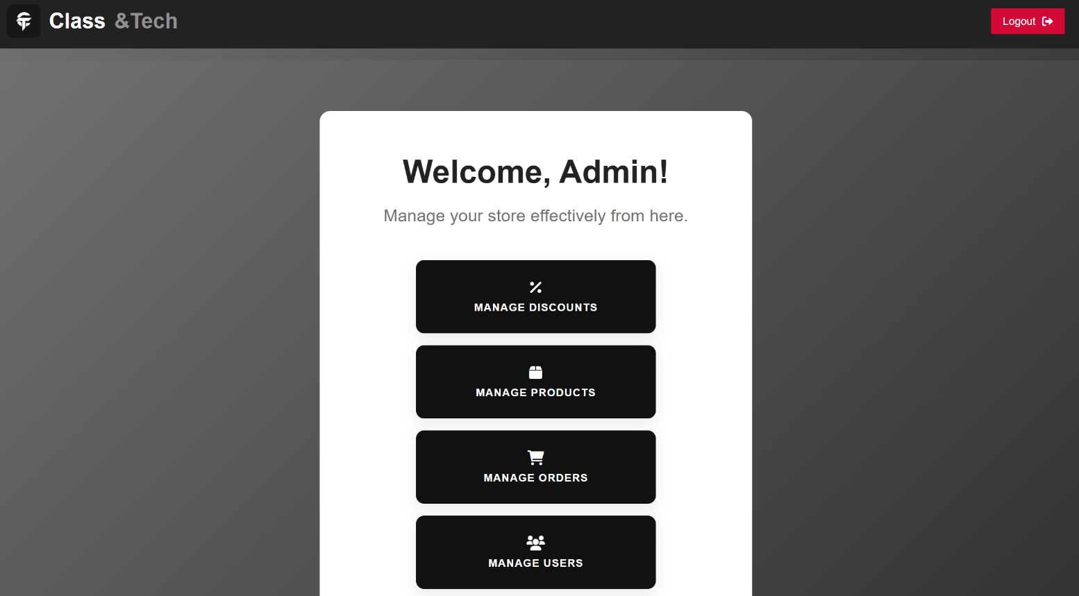

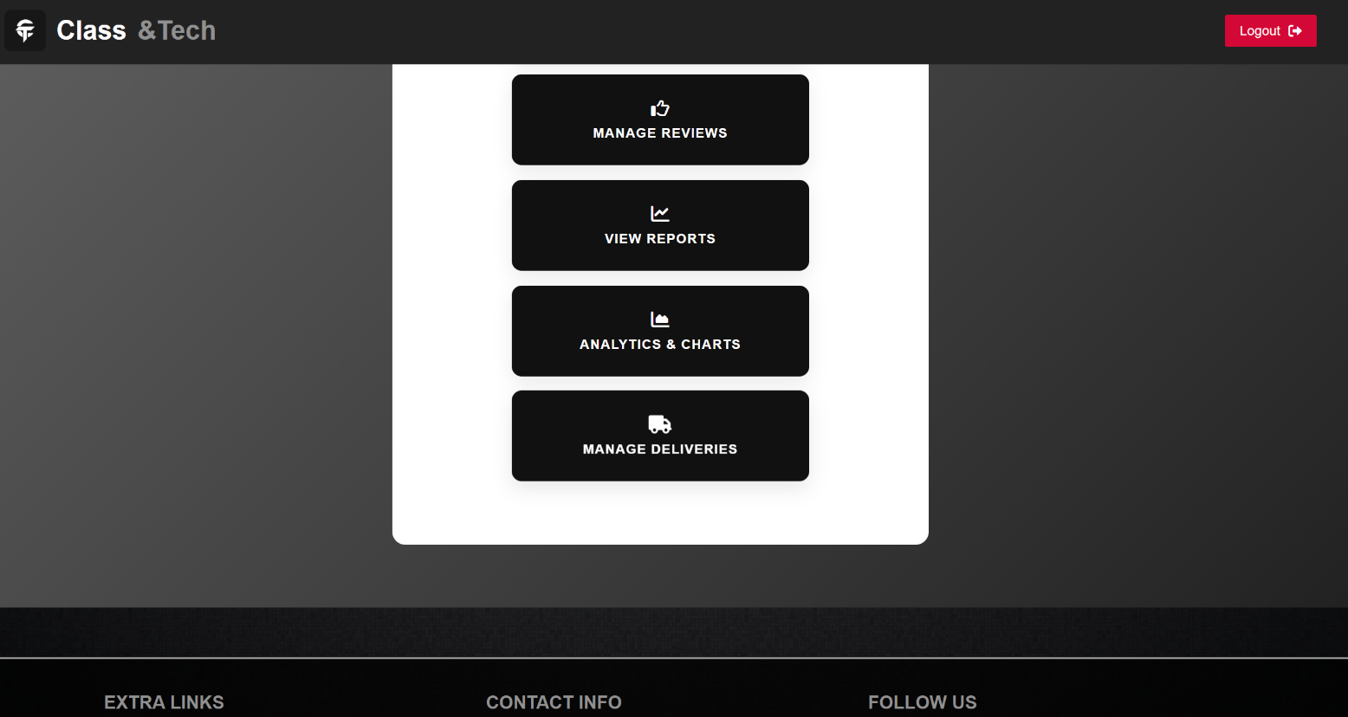

*Figure 19: Admin Page*

## ****Admin Dashboard Workflow****

* The Admin Dashboard is the central control panel for the platform, providing the store administrator with access to all management functions in a single, organized interface. Only users with administrative privileges can access this page. The system enforces this by checking the user session; if the user is not logged in as an admin, they are redirected to the login page, ensuring that sensitive management features remain secure.
* The dashboard opens with a **header** that contains the store logo and a logout button. The logo reinforces brand identity and provides a quick link back to the main index page. The logout button allows the administrator to securely end their session at any time, ensuring that unauthorized users cannot access the admin panel from the same device.
* The main content area of the dashboard includes a welcome message for the administrator and a short description indicating that this is the place to manage the store effectively. This provides clarity to the admin on the purpose of the page.
* The core component of the dashboard is a **grid of action tiles**, each representing a different management function. These tiles are visually distinct, clickable, and arranged responsively in rows of three or four, depending on the screen size. Each tile contains an icon and a descriptive label, providing both visual and textual cues to the administrator. The tiles include the following functions:
* Manage Discounts: Opens the discounts management page where the admin can create, update, or remove promotional offers, coupon codes, and other discount campaigns.
* Manage Products: Opens the products management page where the admin can add new products, update existing product details, manage product images, set prices, and handle stock levels.
* Manage Orders: Opens the orders management page where the admin can view all customer orders, update order statuses, manage returns, and track pending shipments.
* Manage Users: Opens the user management page where the admin can view all registered users, update their roles, deactivate accounts if necessary, and maintain overall user database integrity.
* Manage Reviews: Opens the reviews management page where the admin can monitor customer feedback, approve or remove reviews, and respond to concerns to maintain platform quality.
* View Reports: Opens the reports page where the admin can see sales summaries, performance metrics, and other tabular data to evaluate store performance.
* Analytics and Charts: Opens a visual analytics page where key performance indicators are displayed as charts, graphs, and visual metrics, assisting the admin in making data-driven decisions.
* Manage Deliveries: Opens the delivery management page where the admin can track shipments, assign delivery personnel, and ensure timely fulfillment of orders.
* Each tile responds to user interactions with hover effects and subtle animations to indicate click ability. This visual feedback enhances usability and helps the administrator quickly identify actionable items.
* The layout is responsive, ensuring that all tiles remain organized and readable across different devices, from desktop monitors to tablets and smartphones. The minimum and maximum widths of the tiles are set to adapt automatically, maintaining a professional appearance and ensuring accessibility.
* The Admin Dashboard serves as the **primary navigation hub** for the administrator, allowing access to all critical backend features in a structured and secure manner. It combines clarity, interactivity, and responsive design to ensure that administrative tasks can be performed efficiently and accurately.
* Overall, the dashboard balances **visual appeal and functional accessibility**, providing administrators with a comprehensive overview of their store operations while maintaining strong security measures to protect sensitive data and management controls.

### 4.2.15-Manage Discounts:

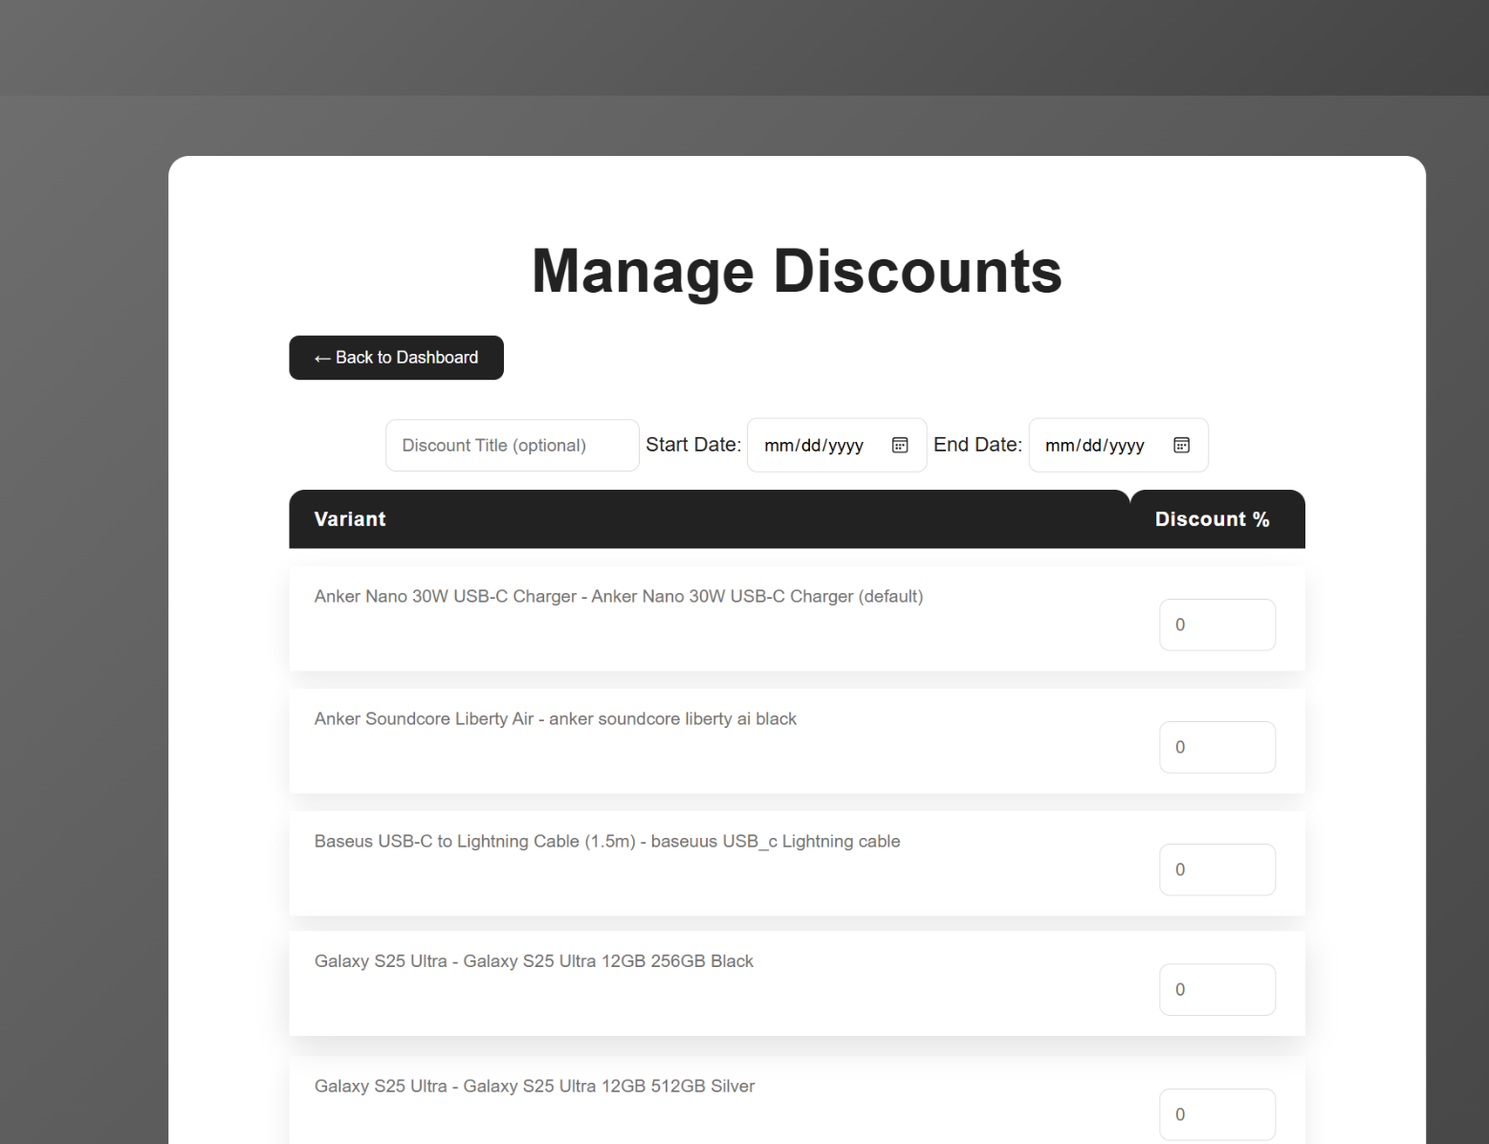

*Figure 20: Manage Discounts*

* The Admin Discounts page is designed to allow the store administrator to **create, manage, and remove discount offers** for product variants. Access to this page is restricted to administrators only. The system enforces this by checking the user session and verifying the user_type; if the user is not an admin, they are redirected to the login page. This ensures that only authorized personnel can manipulate discount data.
* At the top of the page, there is a **header section** with the page title “Manage Discounts” and a button that allows the admin to return to the main dashboard. This provides context and easy navigation back to the main control panel.
* The page is divided into two main sections: **Add Discount Form** and **Existing Discounts Table**.
* The **Add Discount Form** allows the admin to create new discount offers. The form contains input fields for the discount title, start date, and end date. These fields allow optional customization: if no title or dates are entered, the system can inherit values from the last created discount, making it easier to create multiple discounts without repeating information.
* Below the date fields, a **table lists all active product variants** currently in the system. Each row displays the product name, variant name, and a textbox for entering the discount percentage. This allows the admin to assign different discount values for each variant individually. The form also includes a submit button labeled “Add Discounts.” When submitted, the system validates the input, prevents duplicate active discounts for the same variant, and inserts the new discount into the database. Featured status for the product and its variants is updated automatically to reflect the current active discounts.
* The **Existing Discounts Table** displays all previously created discounts, grouped by discount title. Each row contains the product image, product name with variant, the applied discount percentage, and action buttons. The action buttons include a “Save” button to update the discount percentage directly and a “Delete” link to remove the discount. When a discount is deleted, the system checks if any other active discounts exist for the same product; if not, it restores the featured status for the product and its variants. This ensures that the store always highlights products correctly based on active promotions.
* The page uses **responsive design** to maintain usability on different devices. Tables are scrollable on smaller screens, and input elements are optimized for both mouse and touch interaction. Hover effects and subtle button animations improve usability and provide clear visual feedback when the admin interacts with the page.
* The system includes **real-time alert messages** displayed above the add discount form, informing the admin of any errors or warnings during discount creation or deletion. This includes database errors, duplicate discount prevention, or required field alerts.

### 4.2.16-Manage Products:

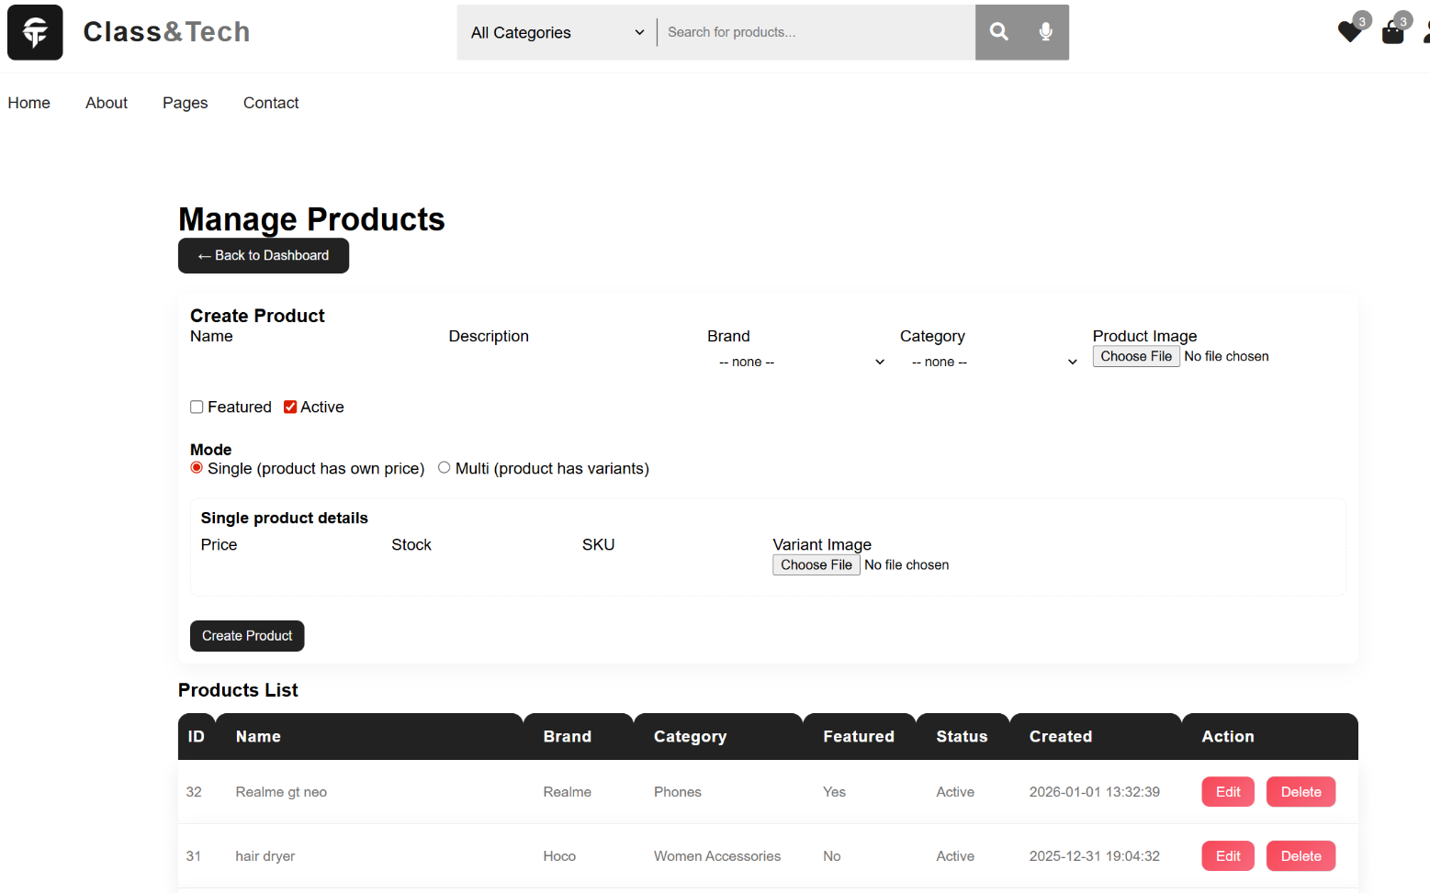

*Figure 21: Manage Products*

* The **Admin Products page** allows the store administrator to create, edit, and manage products and their variants. Access is restricted to admins only; non-admin users are redirected to the login page, ensuring only authorized personnel can modify product data.
* At the top, there is a **header section** with the page title “Manage Products” and a button to return to the main dashboard for easy navigation.
* The page is divided into **Create Product** and **Products List** sections, with an additional **Edit Product** panel appearing when a product is selected for editing.
* The **Create Product form** allows admins to enter the product name, description, brand, category, and upload an image. Admins can choose between **single mode** (product has its own price and stock) or **multi mode** (product has multiple variants). In single mode, fields for price, stock, SKU, and variant image are available. In multi mode, the form dynamically generates rows for each variant with input fields for name, price, stock, SKU, and image, allowing multiple variants to be created at once.
* The **Products List table** displays all products with details such as ID, name, brand, category, featured status, active status, and creation date. Action buttons allow the admin to **edit or delete** a product.
* When editing a product, the admin can **update product details**, replace the primary image, and manage existing variants. Variants are displayed in a table with fields like name, price, stock, and SKU, and actions to **edit or delete** each variant. There is also an **Advanced Add Variant** section that allows adding multiple new variants at once with dynamic row management.
* The page includes **responsive design**, ensuring usability on different devices. Tables are scrollable on smaller screens, and buttons and inputs are optimized for both mouse and touch interactions.
* Real-time **alert messages** are displayed for errors or confirmations, such as creation success, update failures, or deletion confirmations, giving clear feedback to the admin during interactions.

### 4.2.17-Manage Orders:

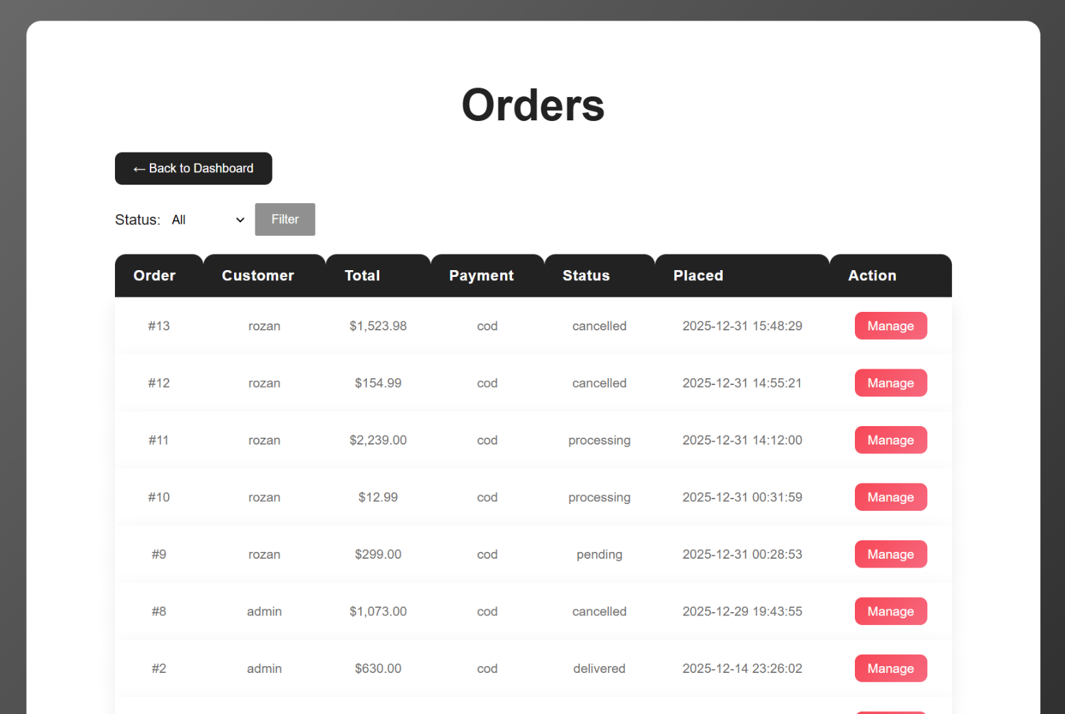

*Figure 22: Manage Orders*

* The **Admin Orders page** allows the store administrator to view, filter, and manage all orders placed on the website. Access is restricted to admin users; anyone not logged in as an admin is redirected to the login page, ensuring only authorized personnel can access order data.
* At the top, the page has a **header section** with the title “Orders” and a **Back to Dashboard** button for easy navigation to the main control panel.
* The page includes a **status filter form** that lets the admin filter orders by their status (Pending, Processing, Completed, Cancelled, or All). This helps quickly find orders that require attention.
* The **Orders Table** lists orders with essential information: order ID, customer name, total amount, payment method, status, and the date/time the order was placed. Each row also includes a **Manage button** that links to detailed order management for that specific order.
* Pagination is implemented to handle large numbers of orders. Admins can navigate between pages using numbered buttons, with the current page visually highlighted.
* The system automatically detects a **timestamp-like column** (e.g., order_date or created_at) to sort orders by the most recent first, while maintaining compatibility with different database structures.
* Responsive design ensures usability across devices, with tables scrollable on smaller screens and buttons optimized for both mouse and touch input.
* Real-time alerts or messages can be integrated to show any issues, such as database errors, although the current implementation primarily provides direct navigation and filtering functionality.

### 4.2.18-Manage Users:

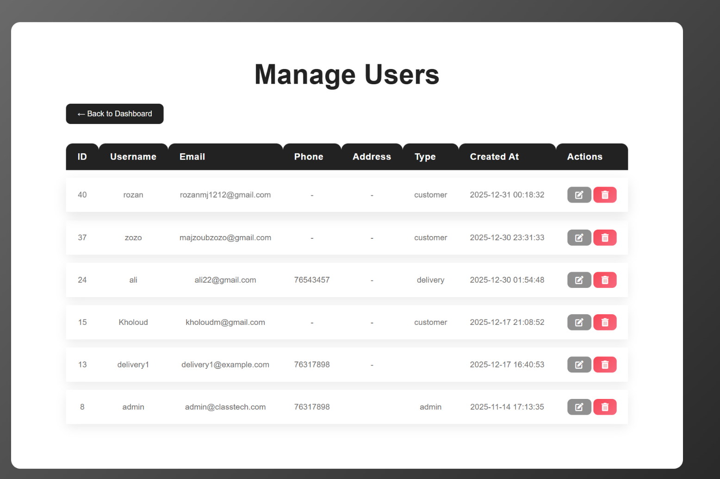

*Figure 23: Manage Users*

* The **Admin Users page** allows the administrator to view, edit, and delete all registered users. Access is restricted to admins; non-admins are redirected to the login page.
* At the top, there is a **header section** with the site logo and a logout button, plus a **Back to Dashboard** button for easy navigation.
* The **Users Table** displays all users with details like ID, username, email, phone, address, type (customer/admin), and account creation date. Each row includes **Edit** and **Delete** actions.
* **Edit User** opens a modal form pre-filled with the user’s information, allowing the admin to update username, email, phone, address, or user type. Submitting the form updates the database.
* **Delete User** immediately removes the selected user after confirmation.

### 4.2.19-Manage Reviews:

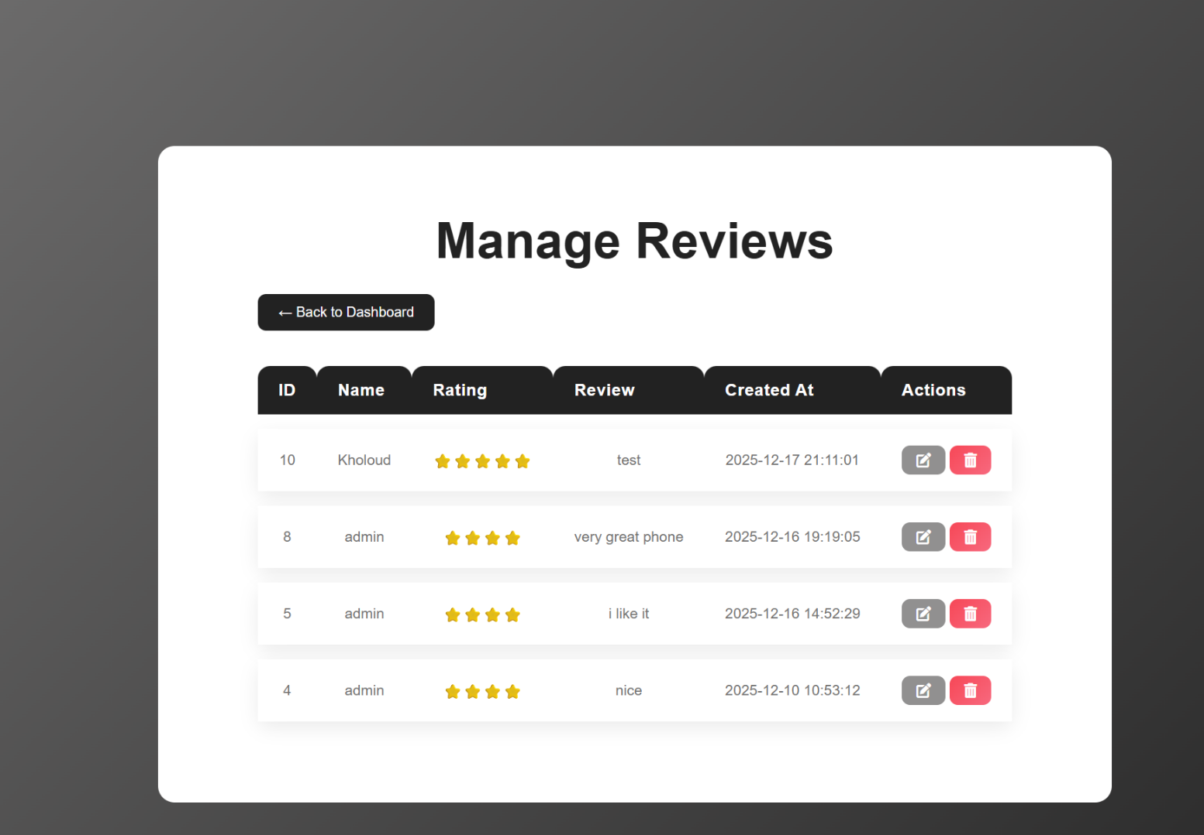

*Figure 24: Manage Reviews*

* The **Admin Reviews page** allows the administrator to view, edit, and delete all product or service reviews submitted by users. Only admins can access this page; others are redirected to the login page.
* The page includes a **header** with the site logo and logout button, and a **Back to Dashboard** button for easy navigation.
* The **Reviews Table** lists each review with ID, username (or “Anonymous” if not available), rating (displayed as stars), review text, creation date, and action buttons.
* **Edit Review** opens a modal form where the admin can change the rating and review text. Submitting the form updates the database.
* **Delete Review** immediately removes the review after a confirmation prompt.

### 4.2.20-View Reports:

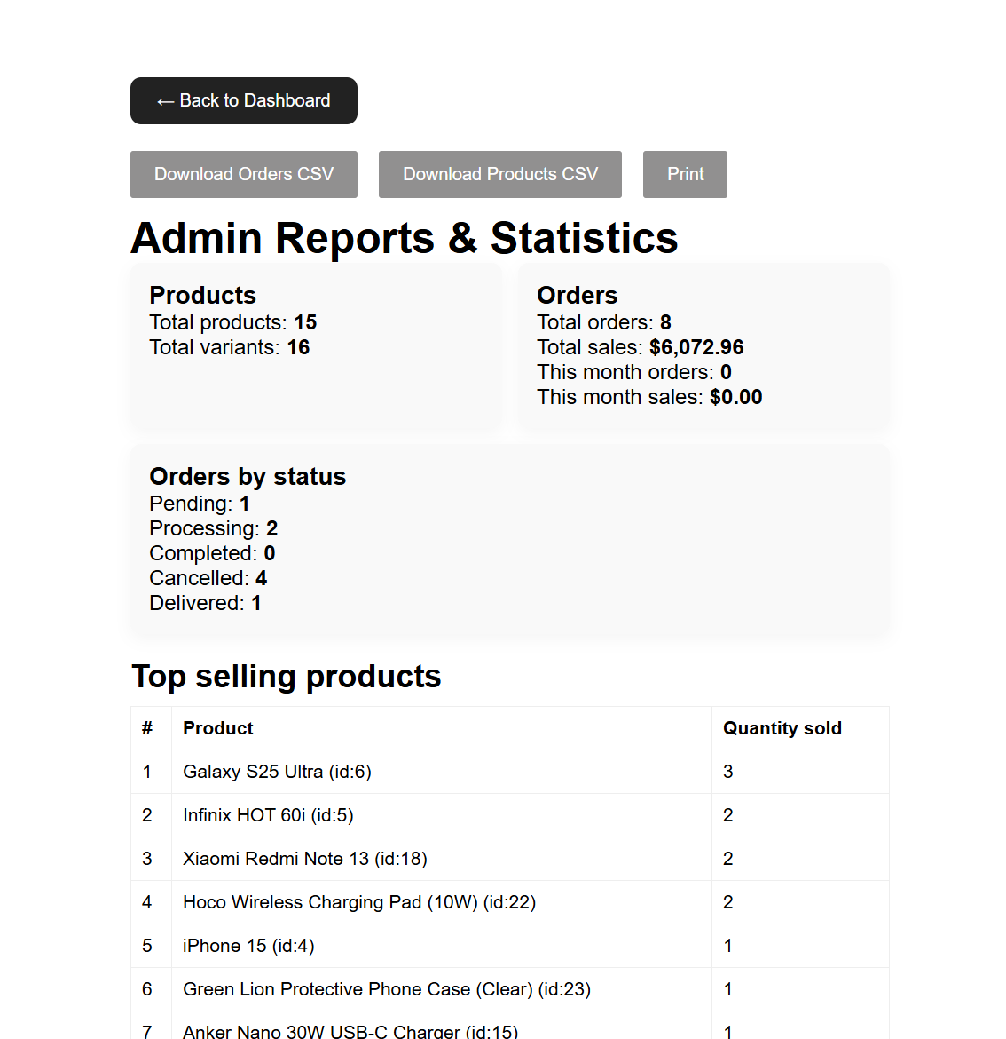

*Figure 25: View Reports*

* The **Admin Reports page** provides administrators with an overview of store statistics and advanced reporting features. Only admins can access this page.
* At the top, there are **buttons** for downloading **CSV reports** for orders and products (via POST requests to prevent accidental downloads on page reload) and a **Print** button for a printable view.
* The page shows **summary cards** with key metrics: total products, total variants, total orders, total sales, orders this month, and monthly sales. It also displays **orders grouped by status**.
* **Top selling products** are listed in a table, showing product name, ID, and quantity sold.
* **Low stock variants** are highlighted in a table to alert the admin about products with stock ≤5.
* **Recent orders** are displayed in a table with order ID, customer, total, status, and placed date.

### 4.2.21-Analytics&Charts:

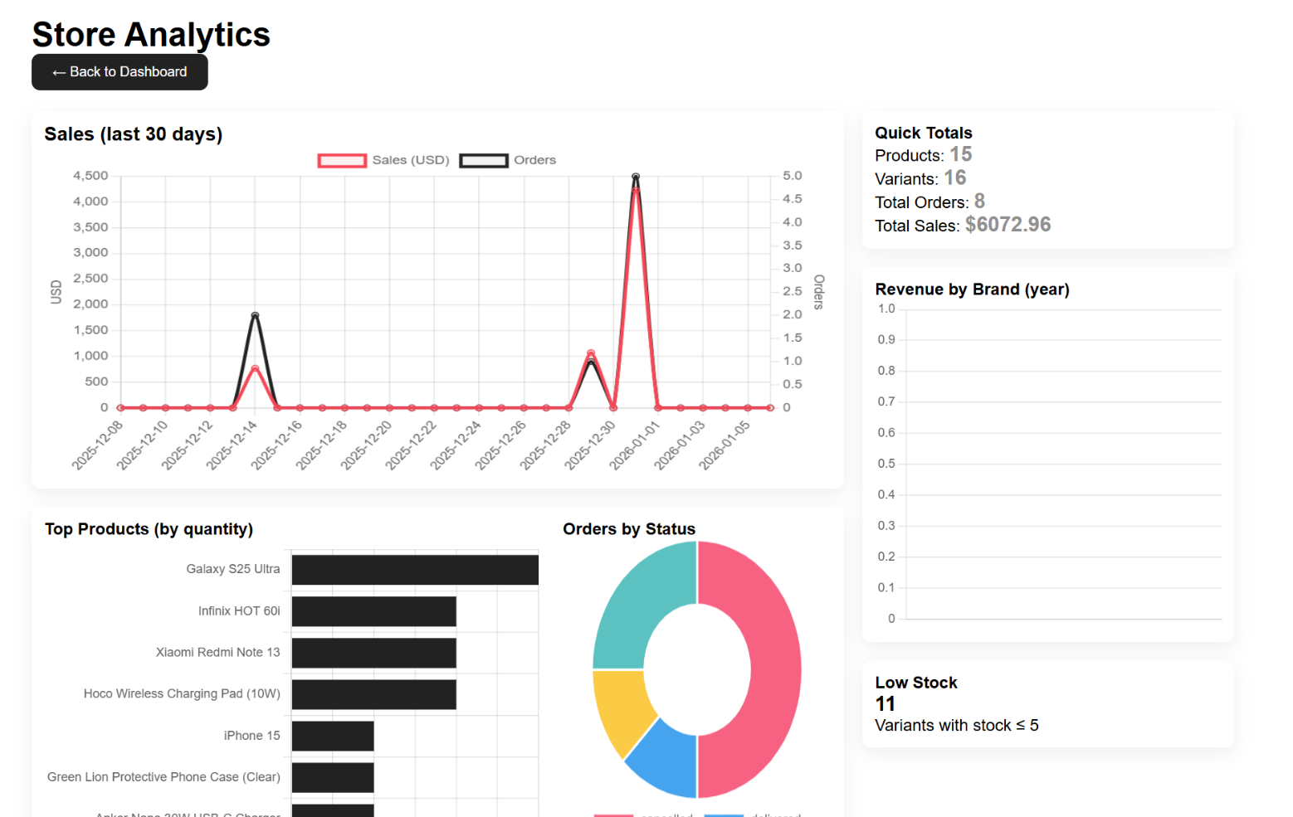

Figure 26: Analytics&Charts

* This page provides **visual analytics for the store** by fetching structured data and rendering it with **Chart.js**.
* **Layout&Sections:**
* **Sales (last 30 days)** – A line chart showing daily **sales in USD** and **number of orders**, allowing you to track trends over the past month.
* **Top Products (by quantity)** – A horizontal bar chart listing the products that sold the most units.
* **Orders by Status** – A doughnut chart showing how many orders are in each status (e.g., pending, processing, completed).
* **Quick Totals** – Displays key metrics: total products, total variants, total orders, total sales, and low-stock variants.
* **Revenue by Brand (year)** – A bar chart comparing total revenue generated by each brand over the year.
* **Low Stock** – Shows the number of variants with stock ≤ 5 to highlight items that need restocking.
* **Functionality:**
* The page **fetches JSON data** asynchronously and updates all charts and stats dynamically.
* Each chart is interactive, responsive, and visually distinguishes different data points with colors.
* A debug section displays errors if the data cannot be fetched or parsed correctly.
* **Purpose:** It provides a **comprehensive overview of store performance**, combining sales trends, top products, order statuses, revenue distribution, and stock levels, all in one interface.

### 4.2.22-Manage Deliveries:

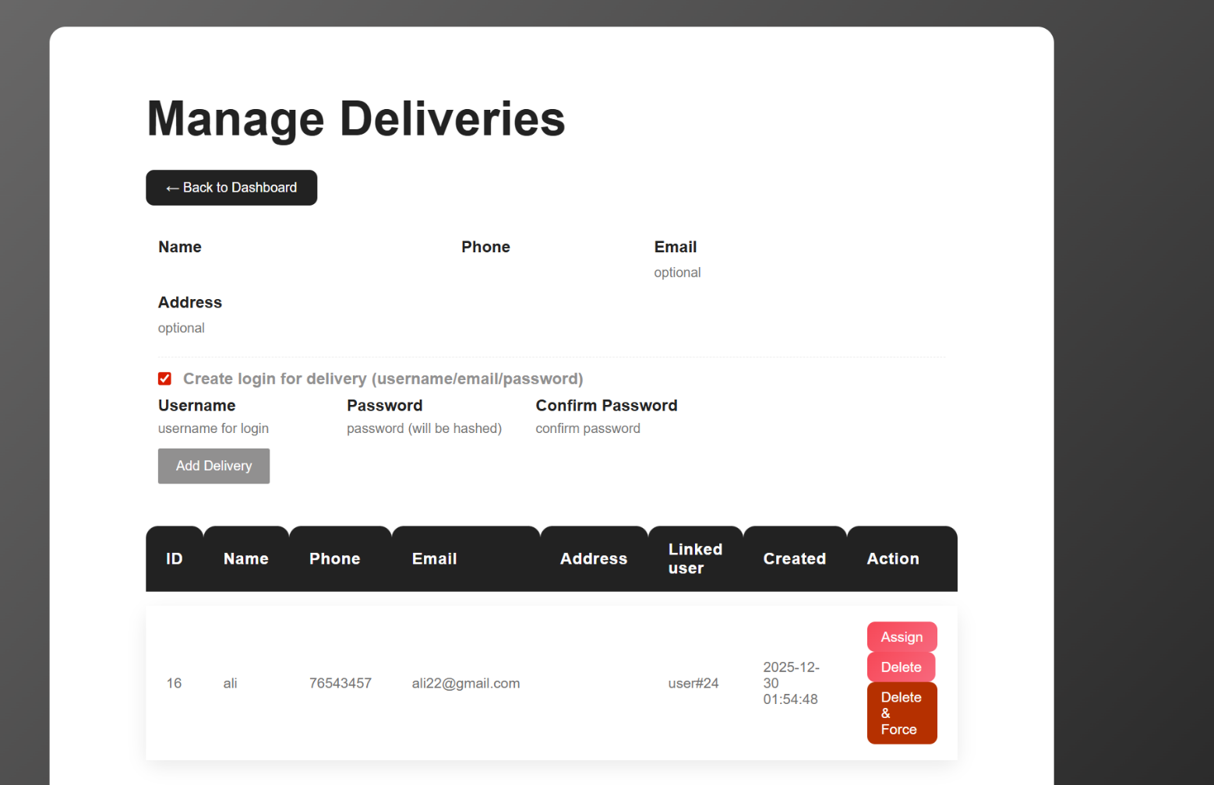

Figure 27: Manage Deliveries

**Workflow:**

* **Purpose of the Page:**
  + - The page is designed to **manage deliveries**. Each delivery can optionally be linked to a **login account** for the delivery person. The system ensures:
    - Users linked to deliveries are correctly marked as **delivery type**.
    - Orders assigned to deliveries are properly managed.
    - Adding or deleting deliveries does not cause data conflicts.
* **Adding a Delivery**
  + - **Required Data**
      * + **Name**
        + **Phone**
    - **Optional Data**
      * + **Email** (used to link an existing user or create a new user)
        + **Address**
        + **Login credentials** (username + password) for creating a delivery account.

**Process**

* **Validate Input:** Name and phone must be provided. If creating a login, username, email, and password are also required. Passwords must match.
* **Check Database Schema:**
  + - Determine whether the users table has the columns type (canonical) or user_type (legacy).
    - Determine if deliveries table has a user_id column for linking accounts.
    - **Database Transaction Begins:** All steps occur in a transaction to ensure consistency.
* **User Handling (if login creation is selected):**
  + - Check if a user with the given email already exists using SELECT ... FOR UPDATE to prevent race conditions.
      * + If the user exists:

Promote the user to type delivery if necessary.

Update phone number if missing.

* + - * + If the user does not exist:

Generate a **unique username** if needed.

Hash the password and insert the new user.

Explicitly set their type as delivery.

* **Insert Delivery Record:**
  + - If the deliveries table supports user_id, link the delivery to the user.
* Otherwise, insert delivery details without linking a user.
* **Commit Transaction:** Ensures all database operations succeed together. If any step fails, changes are rolled back.
* **Deleting a Delivery**
  + - **Parameters**
    - **Delivery ID** (delete=ID)
    - Optional **force deletion** (hard=1) to delete a linked user even if they are not a delivery type.

**Process**

* Start a **database transaction**.
* Fetch the delivery row and its linked user (if any).
* **Unassign orders** that reference this delivery:
* Set delivery_id = NULL.
* Reset status to pending.
* **Handle linked user deletion:**
  + - By default, delete the linked user **only if they are marked as a delivery type**.
    - If hard=1, delete the user regardless of type.
    - **Delete the delivery row** from the deliveries table.
    - **Commit Transaction:** All deletions and updates are executed together safely. If any error occurs, rollback.
* **Displaying Deliveries**
  + - Shows a list of all deliveries with columns:
      * + **ID**
        + **Name**
        + **Phone**
        + **Email**
        + **Address**
        + **Linked User ID** (if a user account exists)
        + **Creation Date**
        + **Actions** (Assign orders, Delete, Force Delete)
* **Data Integrity Features**
  + **Transactions**: Ensures that creation, promotion, and deletion operations either fully succeed or fully fail.
  + **User type enforcement**: Any user linked to a delivery is marked as delivery.
  + **Race condition prevention**: Using SELECT … FOR UPDATE and careful checks prevents duplicate email or username conflicts.
  + **Order management**: Orders linked to a deleted delivery are safely unassigned.

# Chapter 5

## 5.1 - Conclusion:

The Class & Tech Mobile Store system provides a complete, efficient, and reliable solution for managing a mobile phone and technology retail business in an online environment. The system was designed to address the challenges faced by traditional mobile stores, such as manual inventory management, lack of real-time sales insights, inefficient order processing, and limited customer engagement. By automating these processes, the system significantly improves operational efficiency and accuracy.

From an administrative perspective, the platform offers a centralized dashboard that enables store administrators to manage products, categories, users, orders, discounts, and deliveries effectively. Inventory control is enhanced through real-time stock updates, reducing the risk of overselling or stock shortages. The availability of reports and analytical charts allows administrators to monitor sales performance, identify popular products, evaluate promotional strategies, and make informed business decisions based on accurate data.

From a customer perspective, the system delivers a smooth and user-friendly shopping experience. Customers can browse products, view detailed specifications, compare prices, apply discount codes, and track their orders transparently. These features increase customer satisfaction, trust, and loyalty, which are essential for success in competitive e-commerce markets.

Academically, this project demonstrates the practical application of key computer science concepts, including system analysis, database design, software engineering principles, and web development technologies. The project reflects the ability to analyze real-world problems, design suitable technical solutions, and implement them using modern tools and methodologies. Overall, the Class&Tech Mobile Store system successfully meets its objectives and provides a strong foundation for future enhancements and real-world deployment.

## 5.2 - Future Work:

Although the Class&Tech Mobile Store system fulfills its current objectives, several enhancements can be implemented in future versions to improve functionality, scalability, and user experience.

* Online payment gateway integration

Online payment gateway integration is one of the most important future improvements. Adding secure payment methods such as credit cards, digital wallets, or local payment solutions would allow customers to complete transactions fully online. This enhancement would increase convenience, improve transaction security, and reduce manual payment handling.

* Mobile application version

Mobile application development is another significant future enhancement. Developing a cross-platform mobile application for Android and iOS would make the system more accessible and responsive. A dedicated mobile app would enable push notifications for order updates, promotions, and delivery status changes, as well as faster navigation and one-tap interactions for customers.

* AI-based product recommendations

AI-based product recommendations represent an important opportunity for improving sales and personalization. By analyzing customer behavior, purchase history, and browsing patterns, the system could suggest relevant products to users. This would enhance the shopping experience, increase average order value, and help promote new or less-visible products.

* Advanced delivery tracking system

Advanced delivery tracking can also be implemented using GPS technology. This feature would allow customers to track their orders in real time and provide administrators with better visibility into delivery operations. Estimated delivery times and map-based tracking would further enhance transparency and customer satisfaction.

* Multilingual support should be added to ensure inclusivity and accessibility, especially for Arabic and other regional languages. All user interfaces, notifications, and system messages should be fully localized to improve usability for non-English-speaking users.
* Finally, a real-time customer support chat feature could be introduced to allow direct communication between customers and store administrators. This feature would enable faster resolution of customer inquiries related to products, orders, and deliveries, thereby improving customer trust and overall service quality.

These future enhancements aim to transform the Class&Tech Mobile Store system into a more intelligent, scalable, and user-centered e-commerce platform capable of supporting larger businesses and wider markets.

# References:

* Sommerville, I. (2016). Software Engineering (10th ed.). Pearson Education.
* Elmasri, R., & Navathe, S. B. (2017). Fundamentals of Database Systems (7th ed.). Pearson.
* W3Schools. (2024). PHP Tutorial.  
  <https://www.w3schools.com/php/>
* W3Schools. (2024). MySQL Database.  
  <https://www.w3schools.com/mysql/>